**Cybersecurity in networking (with some CCNA)**

*Not necessarily limited to securing the network*

Haoxuan Ge

Newport high school cisco academy

List

Lab 1 factory reset for palo alto firewall

Lab 2 SOHO configuration for pa-220

Lab 3 update license for pa-220

Lab 4 set a URL filtering in pa-220

Lab 5 set a remote user by pfsence

Lab 6 set up cisco asa firewall SOHO configuration

Lab 7 create site to site vpn by PSK

Lab 8 create site to site vpn by self-sign certificate

Lab 9 set up remote access vpn with self-sign cert

Lab 10 set up remote access vpn with SSL

Lab 1

factory reset for palo alto firewall

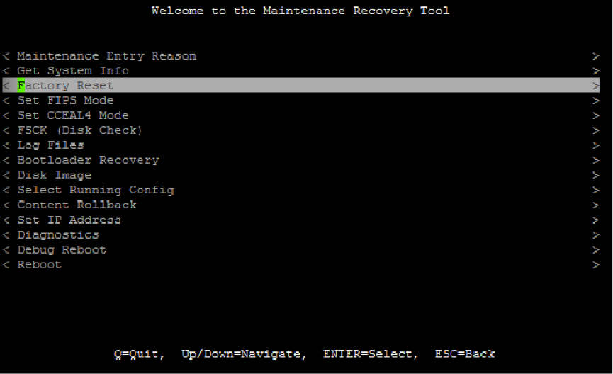

**Palo Alto Firewall Factory Reset**

**Topologies: yes, only 2**

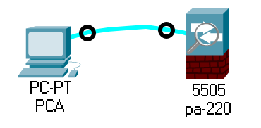

**Background:**

Maybe the password of the firewall is forgotten, or the password is hacked and needs to be reset, I don't know, anyway, the password needs to be reset.

**Step:**

1. Connect console between firewall and PC, it is not need for firewall connect to the ISP and internet
2. Forcibly unplug the firewall, then plug it back in, and this will force restart
3. That is a special time last 5 second during booting, type maint quickly unless it will turn normal mode, then choose maint mode

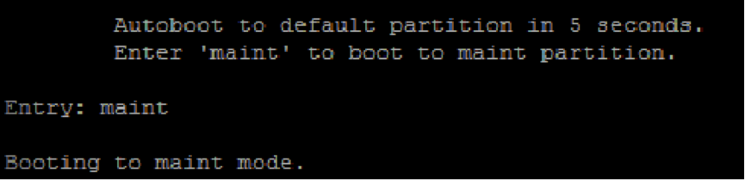

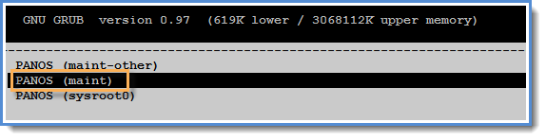

1. Go to factory reset and double clink enter, It will takes a long time

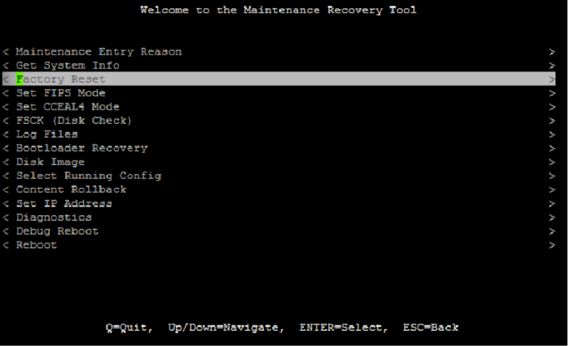

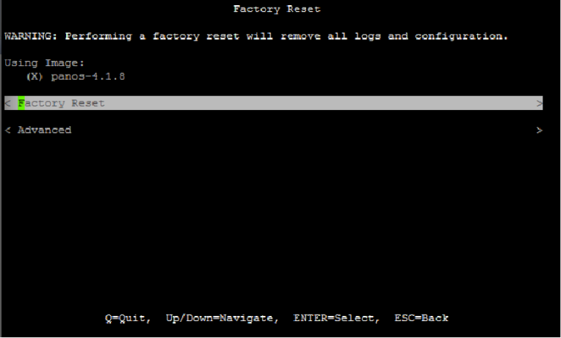

1. Then the firewall will be restored to factory settings, continue to forcibly unplug the power supply and plug it in again, ignore the maint mode, wait a few minutes and directly enter admin/admin to enter the normal mode.

**Possible problems:**

Even if the username and password are set, if the power is cut off, the firewall needs to be reset to the factory settings, which is very troublesome

Lab 2

SOHO configuration for pa-220

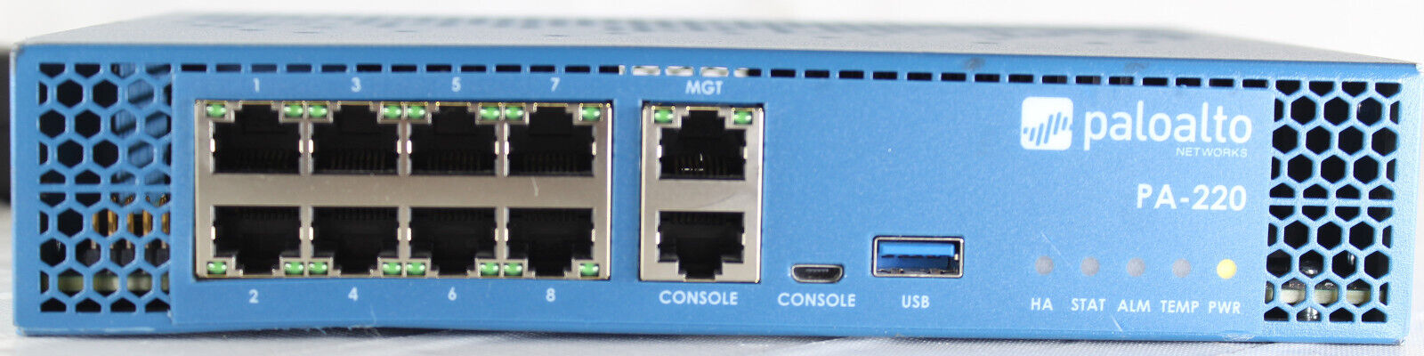

**SOHO configuration of palo alto**

Diagram:

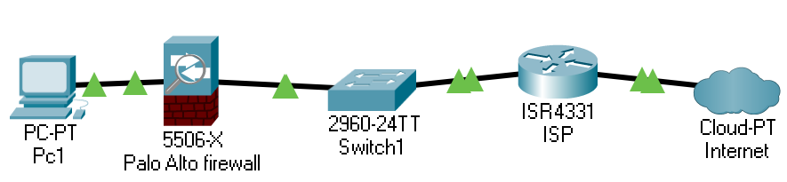

Device:

1 Pc, 1 palo alto firewall, 1 switch what can connect to internet, several cables

Background:

Small Office Home Office (SOHO) is the term for a small office or home office environment and business culture. Organizations, businesses and publications exist to support people who work or run businesses in this environment. The term "virtual office" is sometimes used as a synonym.

SOHO networks can be a mix of wired and wireless computers. Because these networks are designed for businesses, they may also include printers and, in some cases, voice over IP (VoIP) and fax over IP technology.

SOHO networks sometimes run Intranet Web, e-mail, and file servers. These servers can be high-end PCs with increased storage capacity (multi-drive disk arrays).

In a SOHO network, a firewall is a network security system that monitors and controls incoming and outgoing network traffic according to predetermined security rules. A firewall typically creates a barrier between a trusted network and an untrusted network, such as the Internet. Firewalls are classified as network-based or host-based systems. Network-based firewalls sit between two or more networks, usually between the LAN and WAN. They are either software devices running on generic hardware, hardware devices running on dedicated hardware, or virtual devices running on virtual hosts controlled by a hypervisor. Firewall devices can also provide non-firewall functions, such as DHCP or VPN services. A host-based firewall is deployed directly on the host itself to control network traffic or other computing resources. This can be a daemon or service that is part of the operating system, or a proxy application for protection.

Palo Alto Networks Next Generation Firewall (NGFW) uses powerful traffic identification, malware prevention and threat intelligence technologies to provide security teams with complete visibility and control over all networks.

Today's demo is about how to use Palo Alto Firewall to automatically identify untrusted connections in Layer 3 networks and automatically tag them

Step and configuration:

1. Make sure you are using the same subnet as the firewall, open the browser, change the prefix to https://, then enter the address of the firewall, ignore danger warnings, the default username and password are Admin, Admin

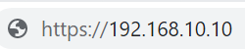

1. Go to the network section, then click on zone, click on a small square that write "add"
2. Create 3 security zones, 2 on the third layer and 1 on the second layer, Note: The third layer has 1 untrusted and 1 trusted, the second layer has only 1 trusted, the name is arbitrary but you It's better to keep an eye on this and leave a similar name for easy memory

as the picture shows:

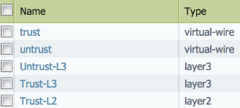

1. Then switch to the interface, still in the same section, Assign the interface of the firewall that connects to the external Internet to the untrusted layer 3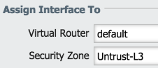

Click ipv4, click static, then add an ip address

Then close this, click on the virtual router, then select the default, then click on the static route, add the ip address of the switch connected to the firewall

1. Exit, click vlan, create a vlan, the name is arbitrary. Then exit and click on Ethernet, click on 3 different interfaces, set the vlan to the vlan you just created, and set the security zone to the only one in layer 2 set before



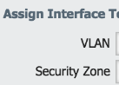

1. Go back to the vlan and set the security zone to the third layer of trust that was just set

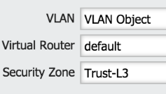

Click on ipv4 to add the last available address in the subnet

1. Then exit, click dhcp, add a dhcp server, then add the ip pool which is currently subnet, gateway and subnet mask, Add first and second dns to 8.8.8.8 and 8.8.4.4 respectively

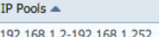

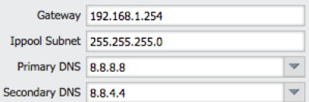

Then exit, enter object, click Security Profile Groups and add one,

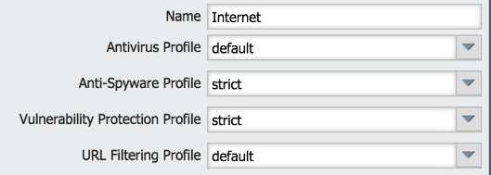

1. Exit its, enter policies and add one security policy rule

Click source and add one in layer 3 what is trust and destination untrust

Click action and set the setting like this 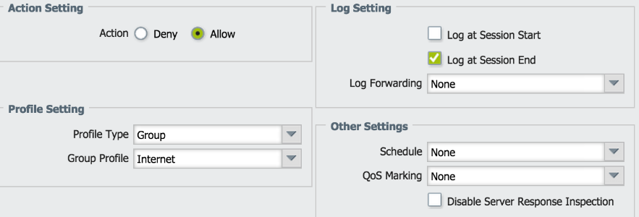

1. Then exit its and add a NAT, click original packet, add a source zone which is that trust zone in layer 3, set the source to untrust layer 3, destination interface are outside to the internet interface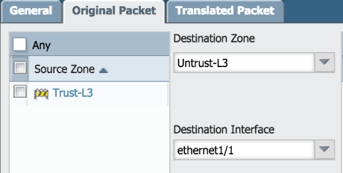

Go to translation packet on top and add the configuration, ignore the destination one

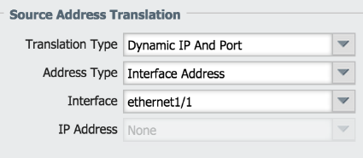

1. Back to main place and get into device, within management interface setting, set the ip subnet and default gateway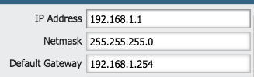

Then exit its, go to services within services within set up section, set the DNS server to 8.8.8.8 and 8.8.4.4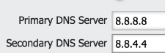

1. Finally, back to the main interface, Click on the upper right corner to submit the changes, otherwise it will not work

Lab 3

update license for pa-220

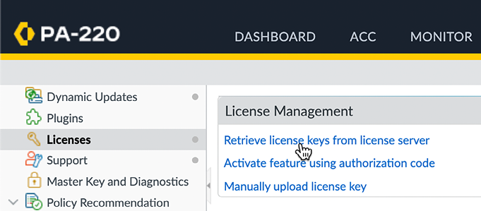

**Update license of palo alto firewall**

Diagram:



Topologies:

1PC, 1 palo alto firewall, 1 device that can connect internet to outside.

Background:

Firewall licensing provides a way for you to select the level of protection you need. Think of it as purchasing an additional feature set. Anything from very basic (probably home) to full protection (financial institutions). Of course, different vendors have eye-catching names for their licensing products. But they all work in very similar ways. Fortinet has FortiGuard. They also have FortiCare, which is the technical support part. Sophos calls them FullGuard and EnterpriseGuard. Meraki is an enterprise license and an advanced security license. In other words, firewall licenses are used to enable various features on the firewall. The same general principles apply regardless of whether the license is for a hardware firewall or a virtual/software firewall.

Of course, newer levels of licenses have more features and fewer issues

Step and configuration:

1. Make sure you are using the same subnet as the firewall, open the browser, change the prefix to https://, then enter the address of the firewall, ignore danger warnings, the default username and password are Admin, Admin



2. Go to device, and enter license, then click on 'Retrieve license from license server'

3. click software then click check now, a list of version will list on screen

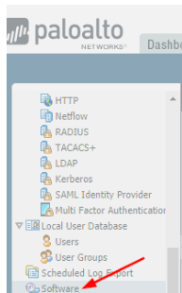

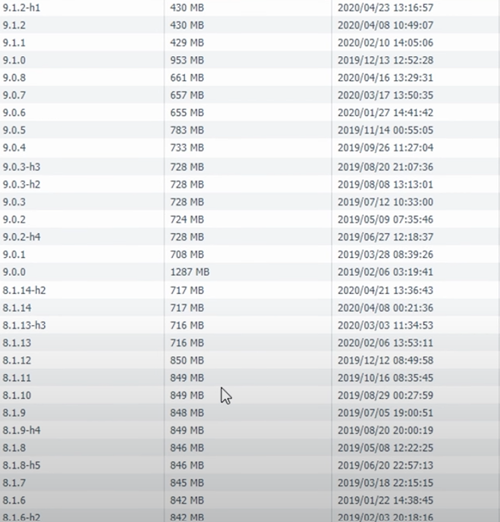

4. click download, note: This thing is a bit stupid. You can only upgrade to the version with the highest minor version at a time. For instance, 8.1.6 cannot be directly upgraded to 10.2. You need to upgrade to 8.1.14, and then upgrade to 9.0, After downloading, the installation will take about 10 to 20 minutes  
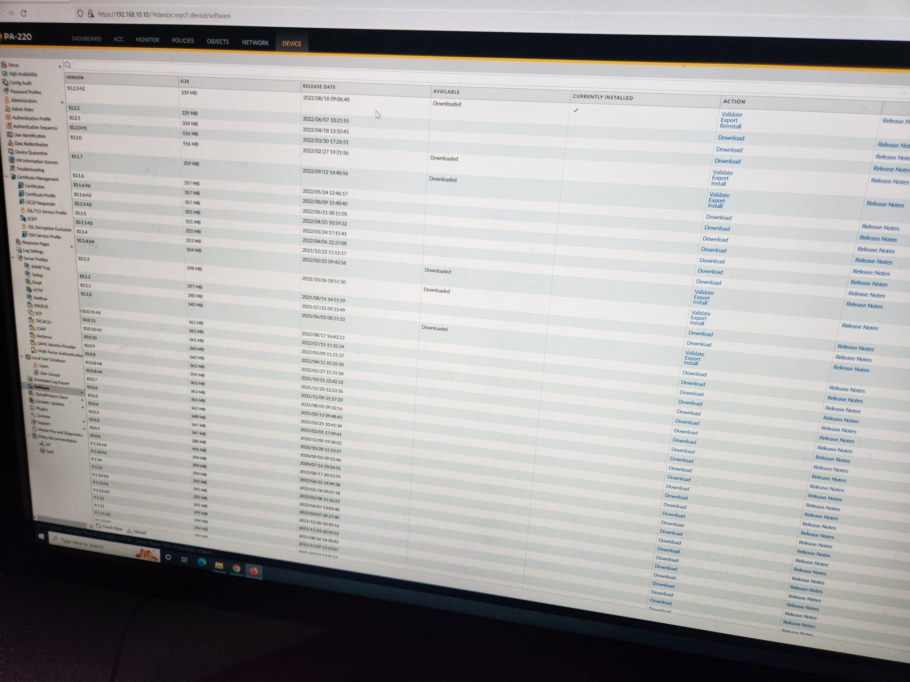

Lab 4

set a URL filtering in pa-220



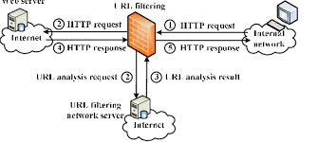Set URL filtering on palo alto firewall

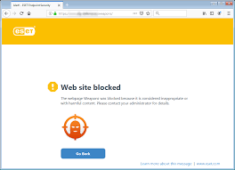

Diagram:



Background:

URL filtering is a method of "blocking" certain URLs from being loaded onto the company network. If employees try to access this URL by manually typing it in or clicking on a link in a search engine, they are redirected to a page that informs them that the content has been blocked.

URL filtering relies on a filtering database that categorizes URLs by topic; each topic in the system is either "blocked" or "allowed". The system was developed primarily for productivity reasons, allowing employers to block sites that are unsuitable for work or designed to waste time.

URL filtering has several key benefits, including.

Minimizing security risks. The first and most significant benefit is that you will reduce the number of security vulnerabilities your organization faces. You will be less susceptible to Internet-based threats.

Improved compliance. You can also avoid liability and stay compliant. Depending on your industry, you may have to comply with stricter cybersecurity and operational standards.

Increase productivity. As a bonus, URL filtering can help you control which sites your employees visit, ultimately improving overall productivity.

You may also want to consider implementing DNS filtering. DNS filtering and URL filtering are both types of Web filtering, but they offer different and separate capabilities. DNS filtering blocks Web content based on DNS queries rather than specific URLs; in other words, it allows you to block entire domains.

Required Devices:

1Pc, 1 device can connect to outside, a palo alto firewall

Step and configuration:

1. Firstly log into palo alto firewall, go to object, in Security Profiles have URL Filtering section, click add

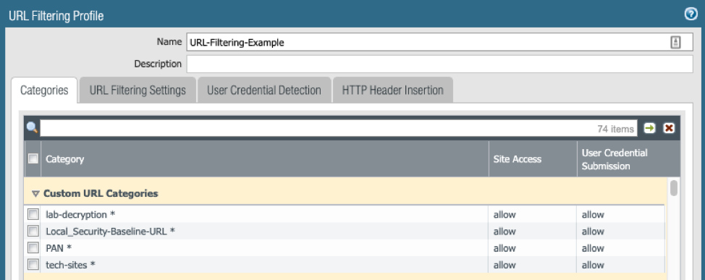

2. go to [www.urlfiltering.paloaltonetworks.com](http://www.urlfiltering.paloaltonetworks.com) determine which type of website want to block or whatever.

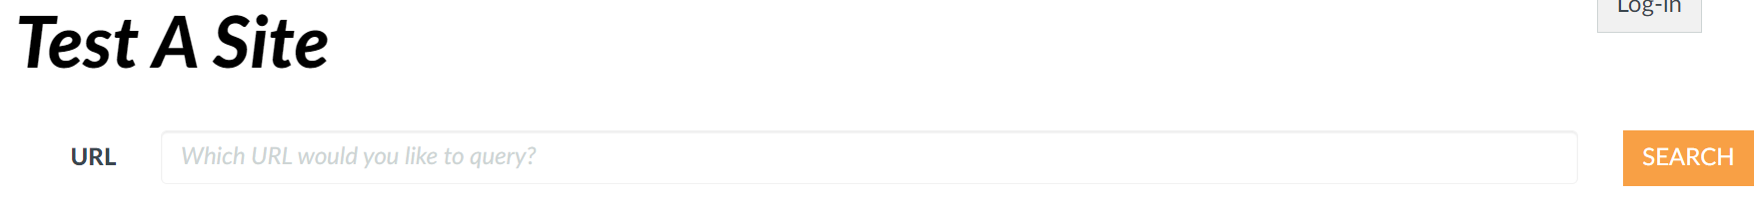

3. Select Categories site access or user credential submission and change the stat if you want,

Allow: allow

Alert: allow but will send a message to the firewall

Block: mean reject

Continue: client need click continue after accessing it

**Note:** Configure user credential detection so that users can submit credentials only to sites in specified URL categories, which reduces the attack surface by preventing credential submission to sites in untrusted categories. If you block all the URL categories in a URL Filtering profile for user credential submission, you don’t need to check credentials.

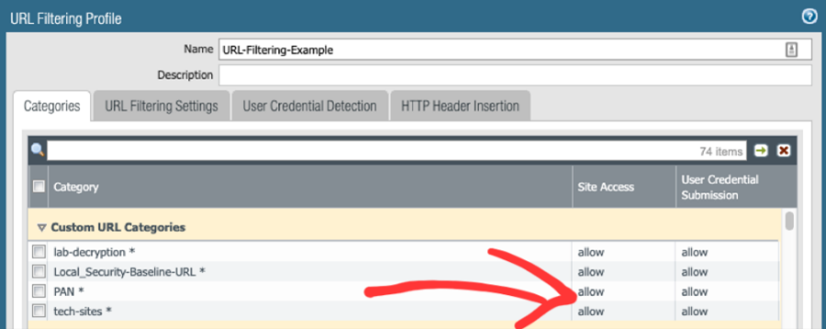  
4. Click User Credential Detection.

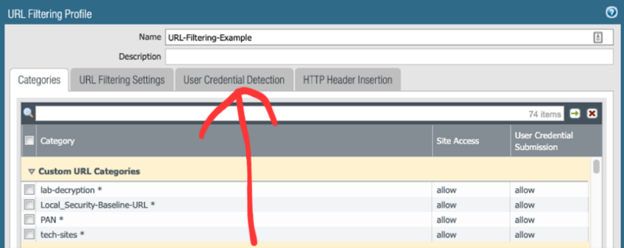

Then select one or two or three methods check for corporate credential submissions

IP User Mapping: for individual one

Domain Credential Filter: User-ID and password, then firewall use id determines the IP address

Group Mapping: the whole group, set by manual.

5. Configure URL filtering profiles to detect phishing and malicious JavaScript in real time using local inline classification.

6. Define URL category exception lists to specify websites that should always be blocked or allowed, regardless of URL category. This is like whitelisting and blacklisting and has a higher priority than general filters

7. Enable Safe Search Enforcement.

8. A container page that logs URL filtering events only.

Select the URL filtering setting. Enable Log only container pages (default) so that the firewall logs only the home page that matches the category and not subsequent pages or categories loaded in the container page.

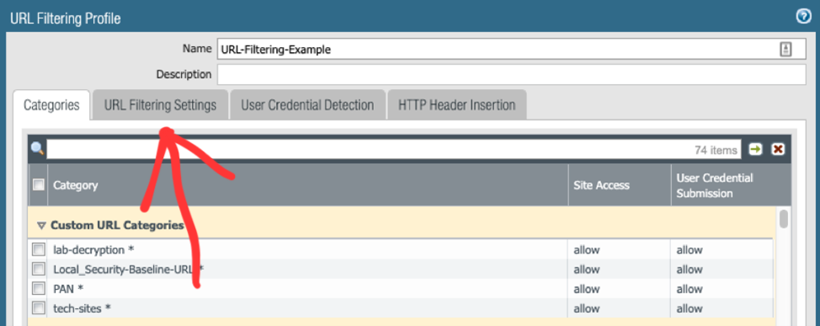

To enable logging for all pages and categories, disable the Log only container pages option.

Then select one or more of the following fields to log: User-Agent, referrer, X-Forwarded-For

User-agent: software that retrieves and presents Web content for end users or is implemented using Web technologies.

Referrer: name of an optional HTTP header field that identifies the address of the web page, from which the resource has been requested

X-forwarded-For: request header is a de-facto standard header for identifying the originating IP address of a client connecting to a web server through a proxy server.

*But, but Mr. Mason, it not working, oh, good question, why do you thick it will work if you just set the config on filter and not do any other things?*

Save and return to the main interface, go to Policy and go to Security. Then, select or create a security policy rule you want to modify(outbound). On the Actions tab, edit the profile settings. For Profile Type, select Profile. A list of profiles will be show on the table. For URL Filtering Profile, select the profile you just created. Finally click OK.

And click up-right corner commit the change

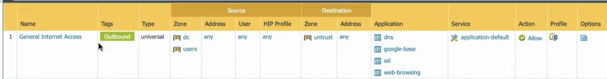

Then, if all goes well, going to a blocked site will show something like this

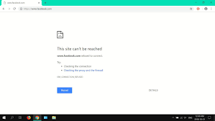

*Although it looks dumb and rude.*

Lab 5

set a remote user by pfsence



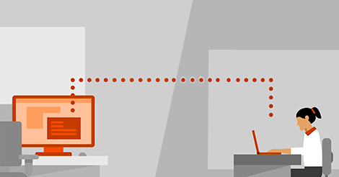

Install a new firewall(pfsense) on a new laptop



Diagram:

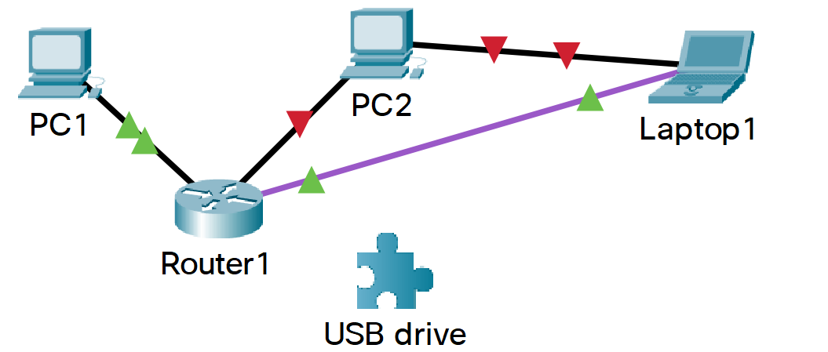

Background:

pfSense is a firewall/router computer software distribution based on FreeBSD. The open source pfSense Community Edition (CE) and pfSense Plus is installed on a physical computer or a virtual machine to make a dedicated firewall/router for a network.[4] It can be configured and upgraded through a web-based interface, and requires no knowledge of the underlying FreeBSD system to manage.

Popular usage areas can be listed below:

LAN/WAN Router,

Wi-Fi hotspot or captive portal

VPN Router

Firewall DHCP / DNS Server

Transparent Squid Proxy Server

Multi WAN Router or Load Balancer

Port Forwarding / NAT (Network Address Translation)

Beyond that, the pfSense® software firewall allows you to add and integrate additional functionality as code, and it is adaptable enough to serve as both a basic firewall and a comprehensive security system.

You can integrate (IPS/IDS) to detect hackers trying to gain access to your network, as well as extensive list blocking, which involves bringing in a database of known malware sites, malicious IP addresses, and hacker sites in case you accidentally stumble across one.

A firewall is only as strong as the rules you set for it, but also how precisely it follows those rules, such as being able to identify traffic that meets your harmful criteria.

pfSense® software is packed with rich features and advanced functionality, ensuring that it always obeys default or custom rules. It also differentiates between traffic from your internal device network and traffic from the open internet, allowing you to define different rules and policies for each.

Step and configuration:

Go to pfsense official page, download the file to USB drive

Also requires a tool to create a bootable USB drive

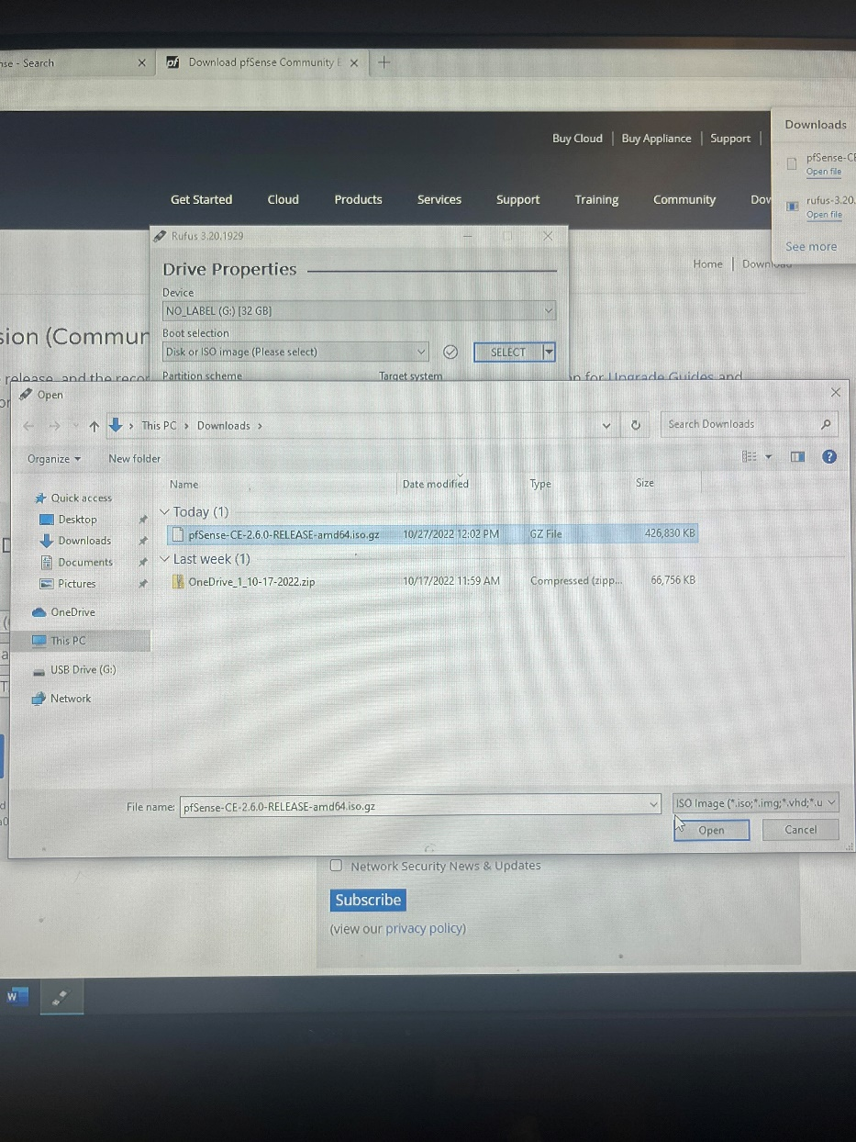

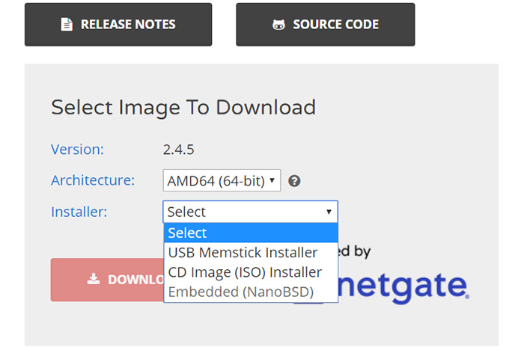

then unzip

If the laptop storage drive is already empty, then just plug the USB drive into any port and wait for the computer to start the installation process, however, if you have installed any other OS that you want to keep, you will need to boot into the BIOS

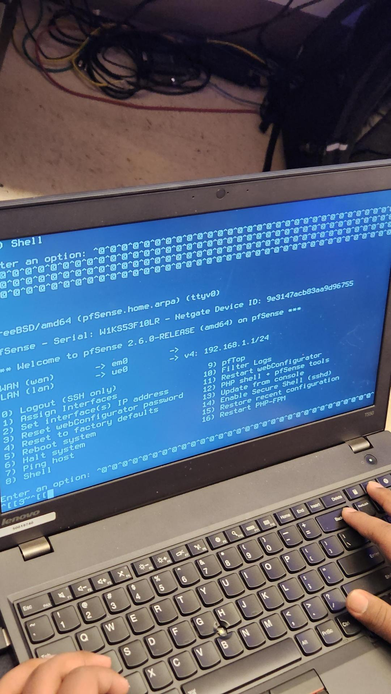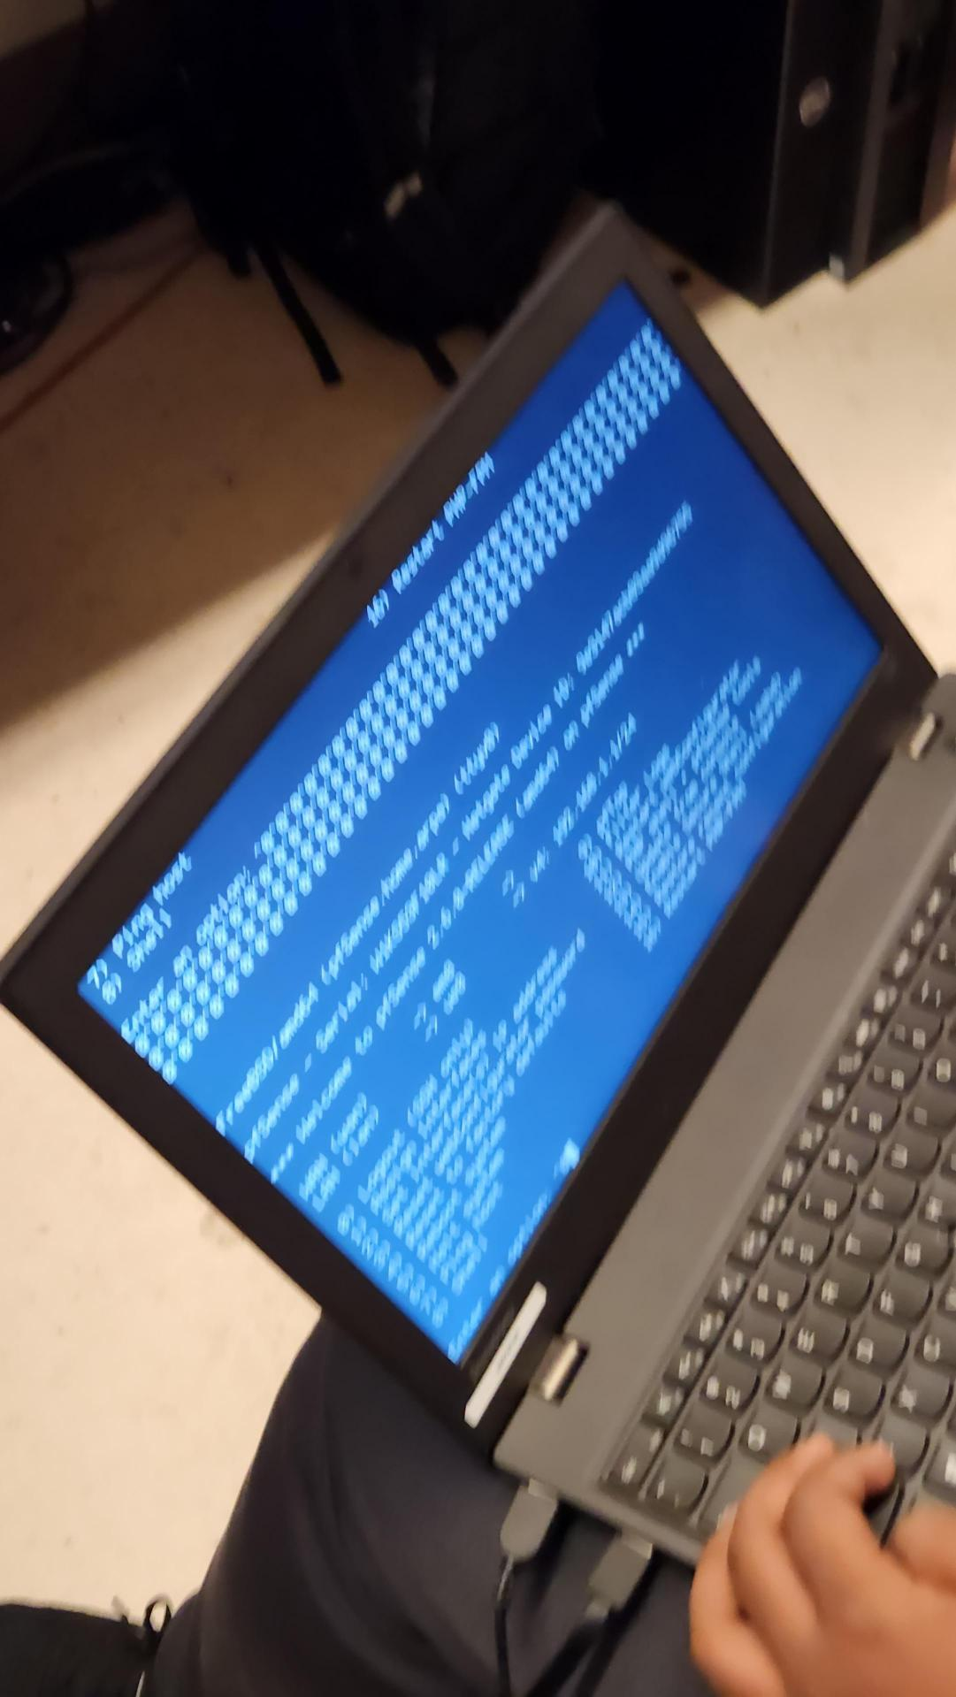

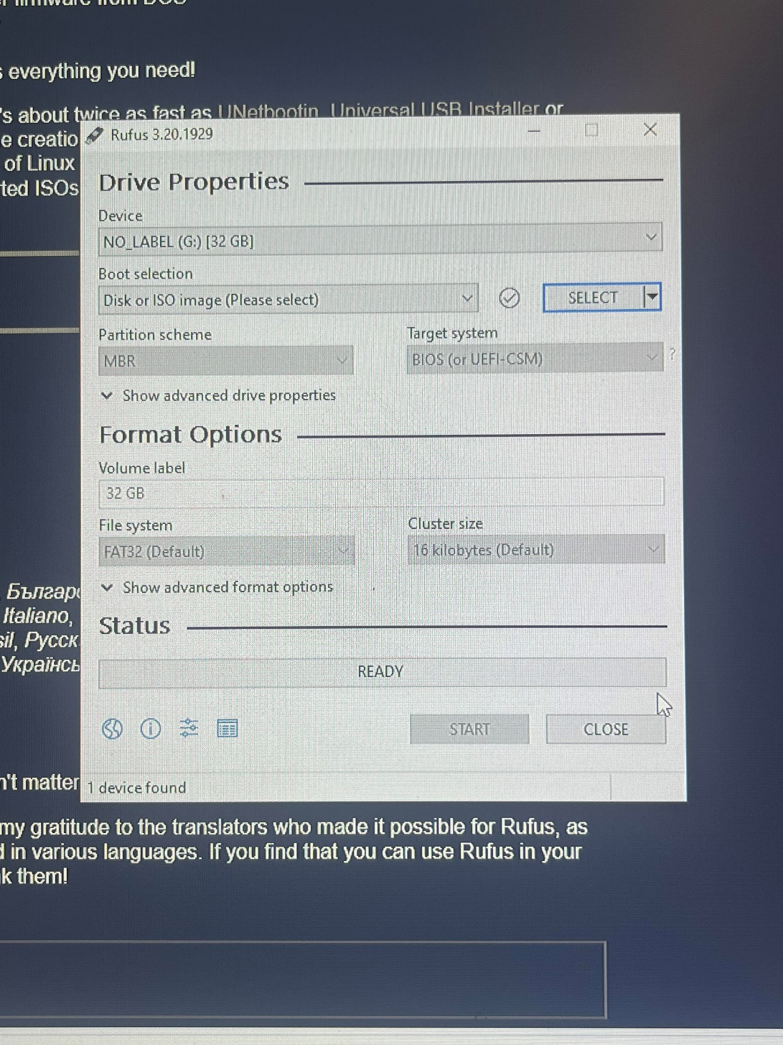

Afterwards, choose between three options: Install pfSense, Start Rescue Shell, or Restore config.xml – choose the first one, and leave it as Default in Keymap Selection. Next, in the Partitioning section, will get four options: Automatic, Manual, Shell, or Automatic (ZFS) - I chose Automatic (Guided Disk Setup) and then it will ask if you want to use the entire disk or create a small partition Available space exceeded. Then it will need to sign the LAN interface name

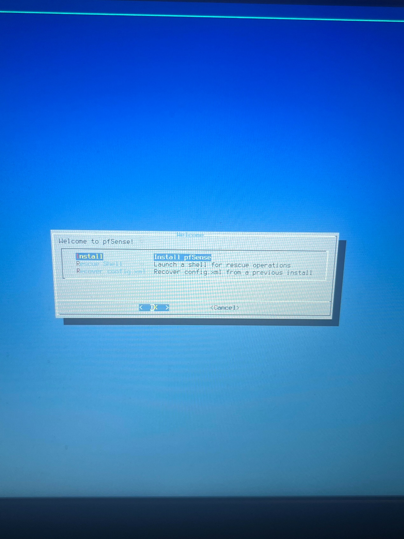

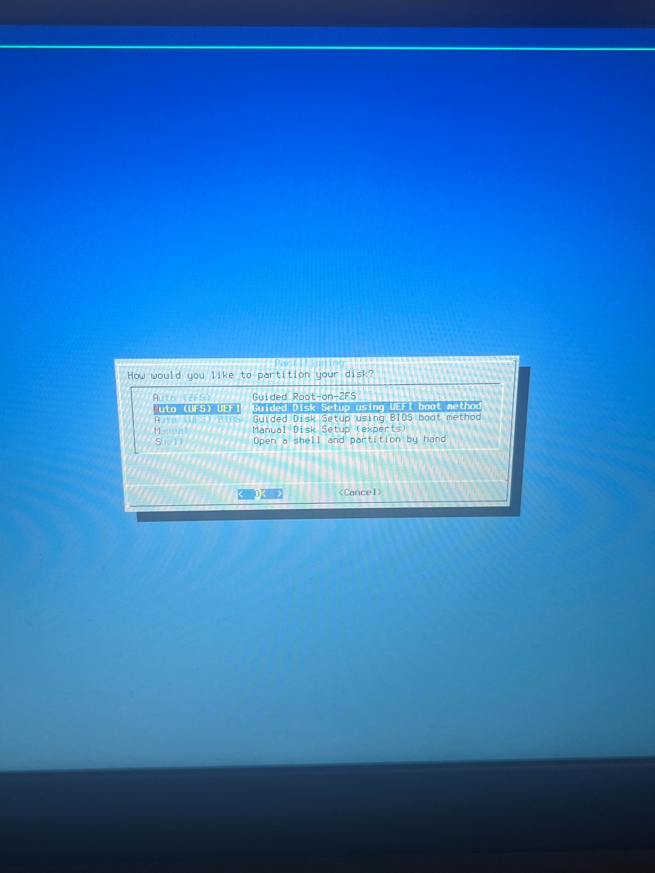

At this point, take two cables, one connecting the WAN port (the one you set up on the pfSense laptop) to the router that connect to the internet, and the other connecting the LAN port to the computer so you can access the GUI. After connecting the client device to the pfSense router, open a browser and enter the LAN IP that was set earlier during configuration (by default it is 192.168.1.1 and admin/admin) 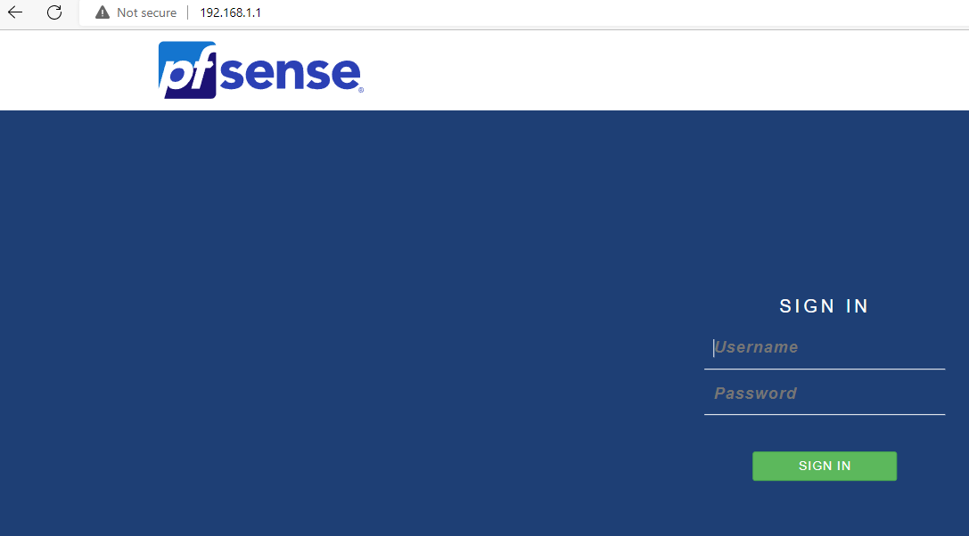

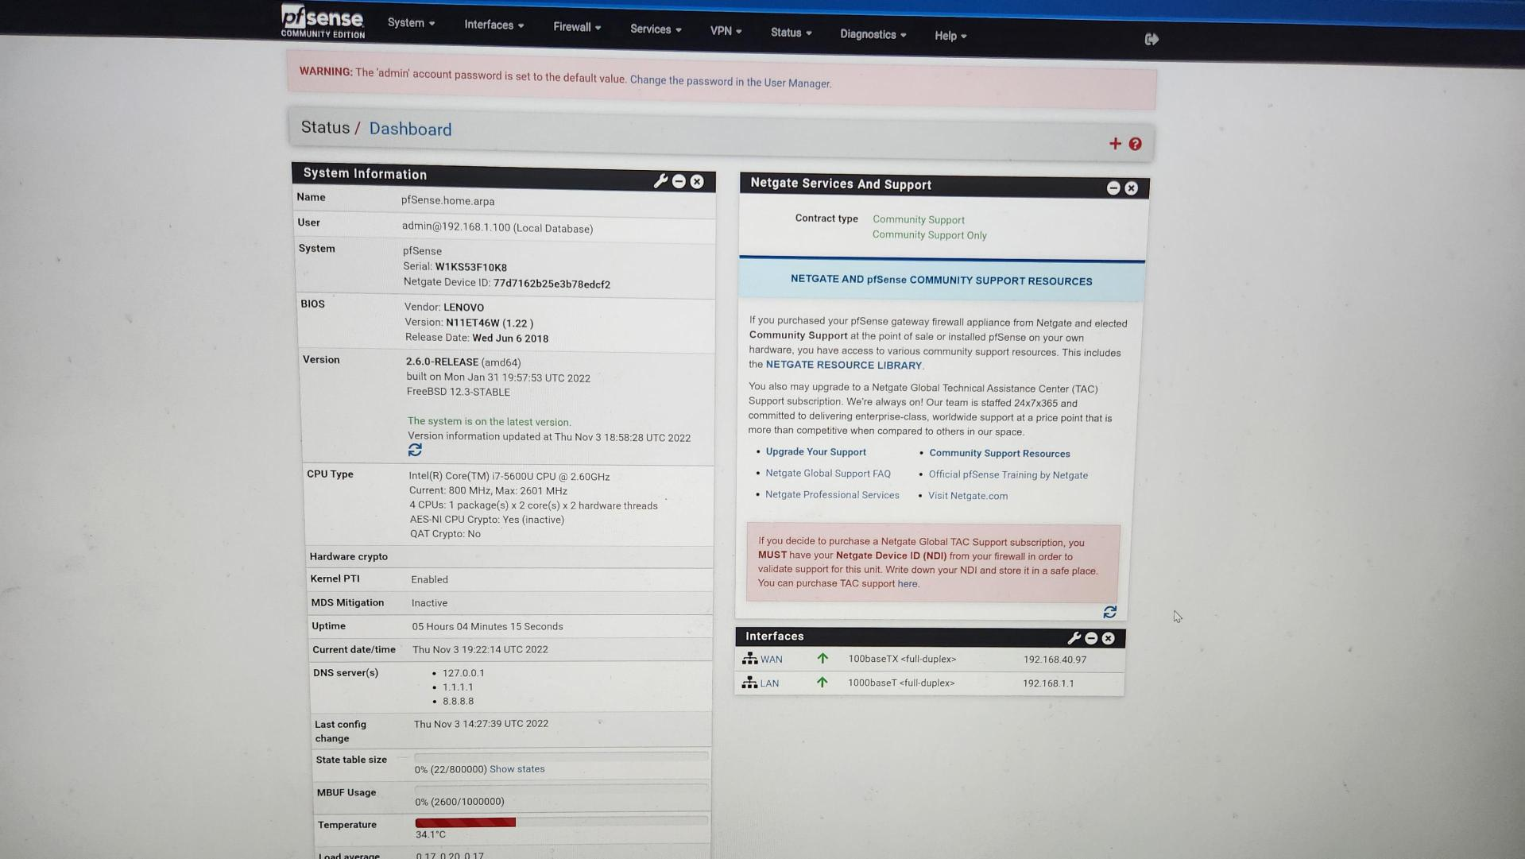

Go to port forward in Nat section

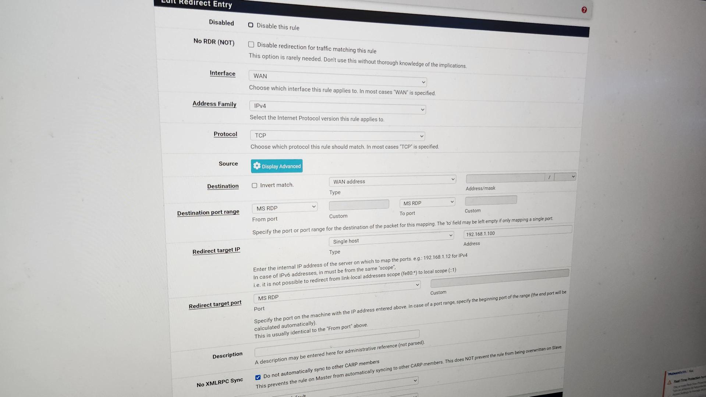

Finally go to remote desktop which is on desktop, type another one PC IP address, it should be good

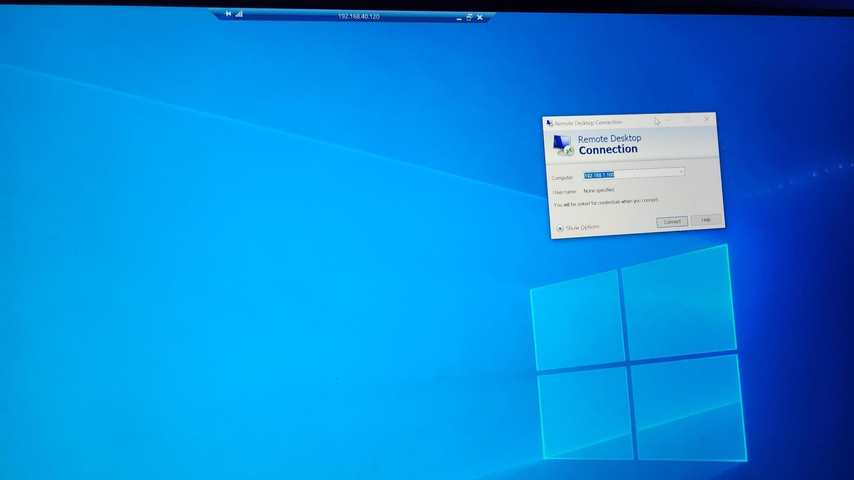



Problem:

Lab 6

Set up SOHO configuration on cisco asa firewall

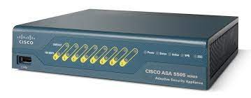

*Not finish yet, for some reason*

Cisco asa SOHO configuration

Diagram:

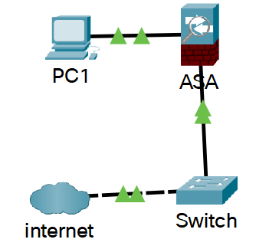

Background:

Small Office Home Office (SOHO) is the term for a small office or home office environment and business culture. Organizations, businesses, and publications exist to support people who work or run businesses in this environment. The term "virtual office" is sometimes used as a synonym.

SOHO networks can be a mix of wired and wireless computers. Because these networks are designed for businesses, they may also include printers and, in some cases, voice over IP (VoIP) and fax over IP technology.

SOHO networks sometimes run Intranet Web, e-mail, and file servers. These servers can be high-end PCs with increased storage capacity (multi-drive disk arrays).

In a SOHO network, a firewall is a network security system that monitors and controls incoming and outgoing network traffic according to predetermined security rules. A firewall typically creates a barrier between a trusted network and an untrusted network, such as the Internet. Firewalls are classified as network-based or host-based systems. Network-based firewalls sit between two or more networks, usually between the LAN and WAN. They are either software devices running on generic hardware, hardware devices running on dedicated hardware, or virtual devices running on virtual hosts controlled by a hypervisor. Firewall devices can also provide non-firewall functions, such as DHCP or VPN services. A host-based firewall is deployed directly on the host itself to control network traffic or other computing resources. This can be a daemon or service that is part of the operating system, or a proxy application for protection.

Compare and contrast to palo alto firewall:

They all have IDS/IPS functionality, Network Antivirus & Anti-Spyware, Site to Site IPSec VPN support, Support for static and dynamic routing protocols

Palo alto also has Basic DLP functionality, IAM, DNS proxy functionality, but cisco does not

Cisco Firewall is equipped with a Talos Intelligence Unit, while Palo Alto is equipped with a Unit 42 Intelligence Unit.

Cisco Firewall focuses on networking and integrated security policies, while Palo Alto focuses only on security.

Cisco Firewall has a variety of unique features such as wireless switching, firewall, and routing, while Palo Alto offers BGP, a routing-based VPN.

Cisco Firewall is a low-cost service, while Palo Alto is a high-cost solution.

All in all, Cisco firewall is an excellent choice for enterprises seeking a wide range of security services that interact with their firewalls, and customers rave about the company's customers. When performance and advanced features are more important than price, Palo Alto is a good choice

Step and configuration:

Plug in the power supply, connect the cable, I don't know why this power supply is so difficult to use, every time I plug it in, it flashes once and then disappears, the success rate is extremely low, if you want to successfully connect to the power supply, you need to plug it in at least 15 times on average: /

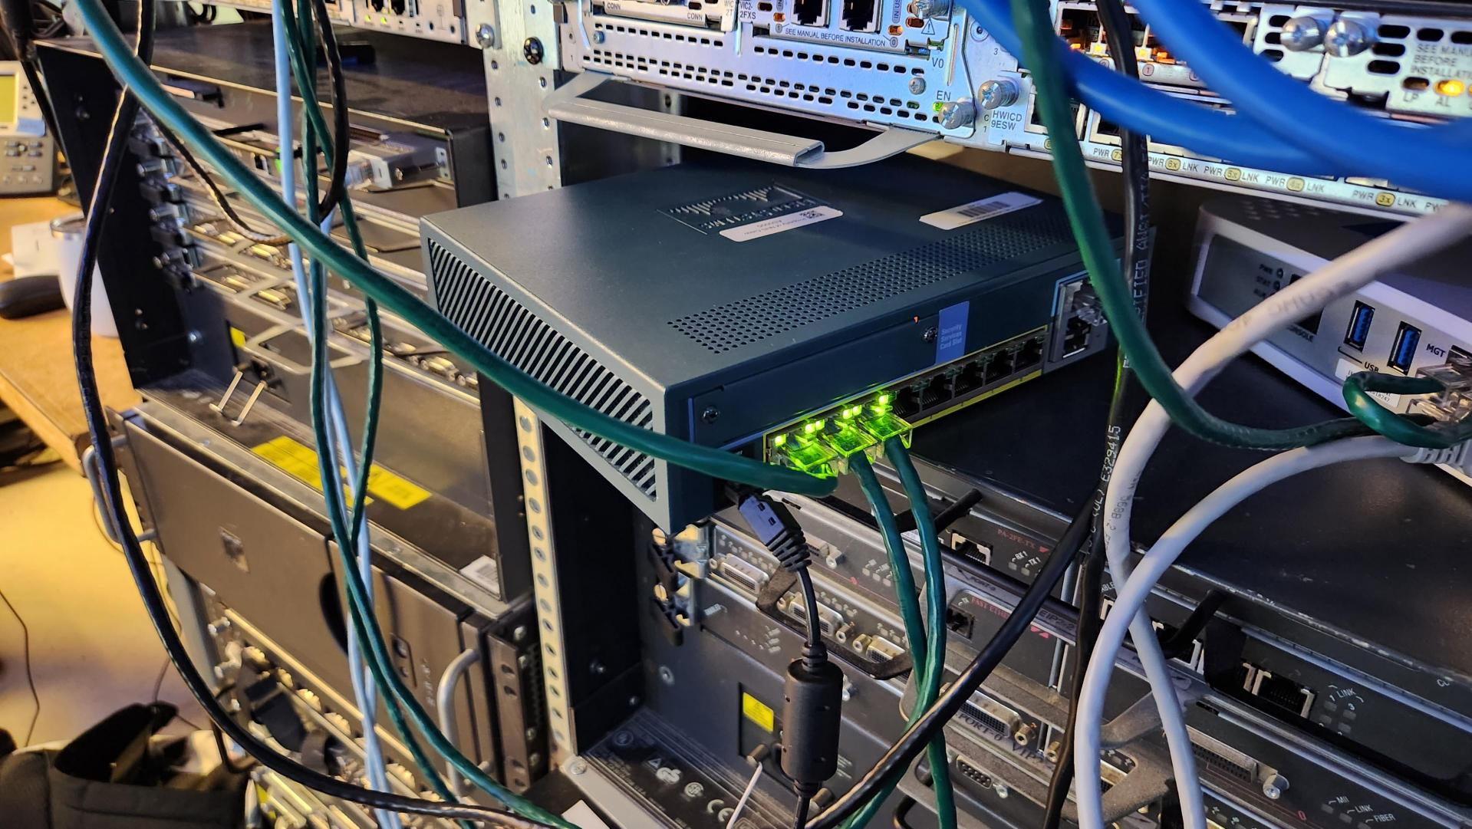

console into it, after entering the global config mode, factory reset it

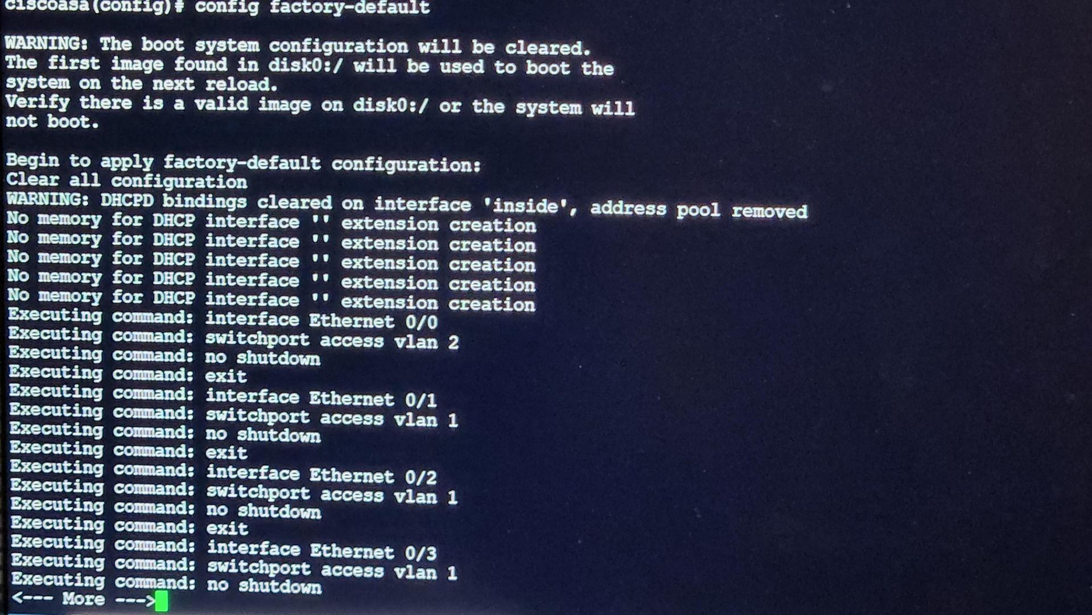

Download ASDM file:

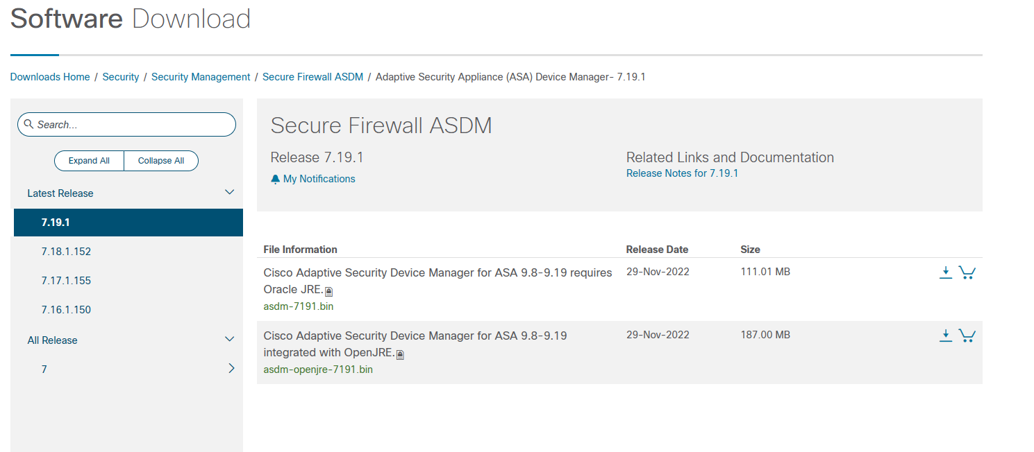

Configure static LAN address

- - - - - - - - - - - - - - - - - - - - - - - - - -To be continued- - - - - - - - - - - - - - - - - - - - - - -

Lab 7

Set up SOHO configuration on pa-410

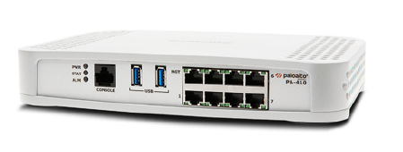

Config SOHO configuration of pa-410

Diagram:



Background:

Small Office Home Office (SOHO) is the term for a small office or home office environment and business culture. Organizations, businesses, and publications exist to support people who work or run businesses in this environment. The term "virtual office" is sometimes used as a synonym.

SOHO networks can be a mix of wired and wireless computers. Because these networks are designed for businesses, they may also include printers and, in some cases, voice over IP (VoIP) and fax over IP technology.

SOHO networks sometimes run Intranet Web, e-mail, and file servers. These servers can be high-end PCs with increased storage capacity (multi-drive disk arrays).

In a SOHO network, a firewall is a network security system that monitors and controls incoming and outgoing network traffic according to predetermined security rules. A firewall typically creates a barrier between a trusted network and an untrusted network, such as the Internet. Firewalls are classified as network-based or host-based systems. Network-based firewalls sit between two or more networks, usually between the LAN and WAN. They are either software devices running on generic hardware, hardware devices running on dedicated hardware, or virtual devices running on virtual hosts controlled by a hypervisor. Firewall devices can also provide non-firewall functions, such as DHCP or VPN services. A host-based firewall is deployed directly on the host itself to control network traffic or other computing resources. This can be a daemon or service that is part of the operating system, or a proxy application for protection.

Palo Alto Networks Next Generation Firewall (NGFW) uses powerful traffic identification, malware prevention and threat intelligence technologies to provide security teams with complete visibility and control over all networks.

Compared to PA-220, it has the same feature, but PA-410 have better App-ID firewall throughput, threat prevention throughput, IPsec VPN throughput and connections per second, with a fancy looking

Step and configuration:

Firstly, console into firewall, disable ZTP mode, otherwise there is never a changing can be committed

Connect firewall and PC, make sure firewall already connected to the internet, type address on browser (https 192.168.1.1) and username password (admin, admin)

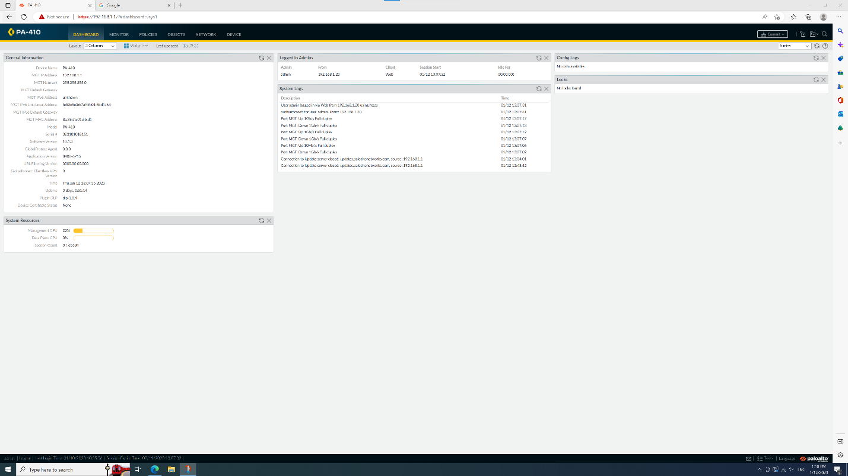

Go to the network section, then click on zone, click on a small square that write "add"

Create 3 security zones, 2 on the third layer and 1 on the second layer, the third layer has 1 untrusted and 1 trusted, the second layer has only 1 trusted, the name is arbitrary but it is better to keep an eye on this and leave a similar name for easy memory

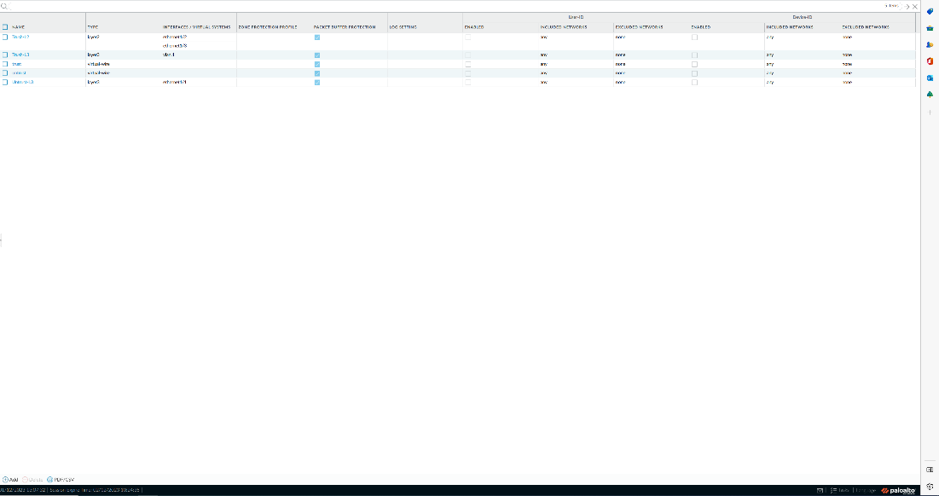

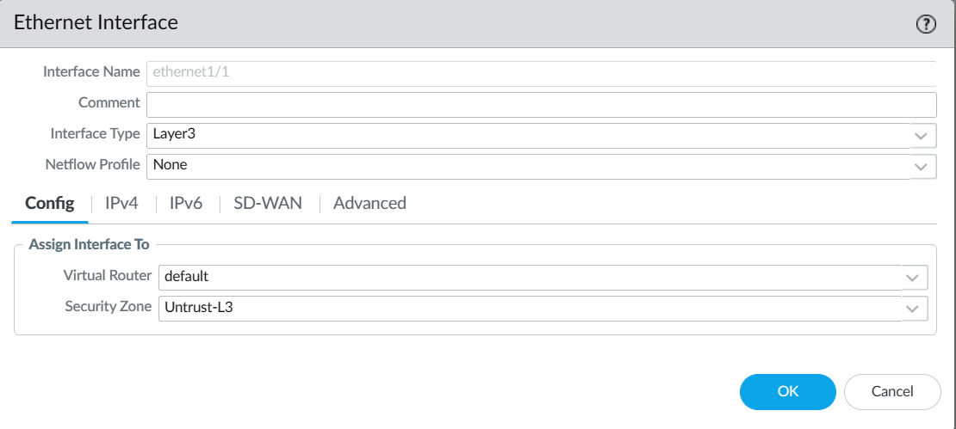

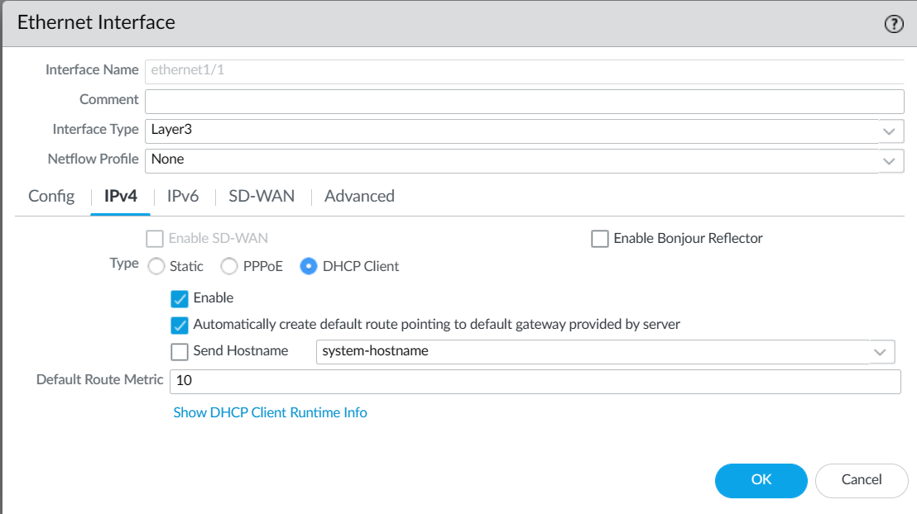

switch to the interface, still in the same section, Assign the interface of the firewall that connects to the external Internet to the untrusted layer 3

Click ipv4, click static, add an ip address

Create 3 zones:

Untrust-L3, Type Layer3

Trust-L3, Type Layer3

Trust-L2, Type Layer2

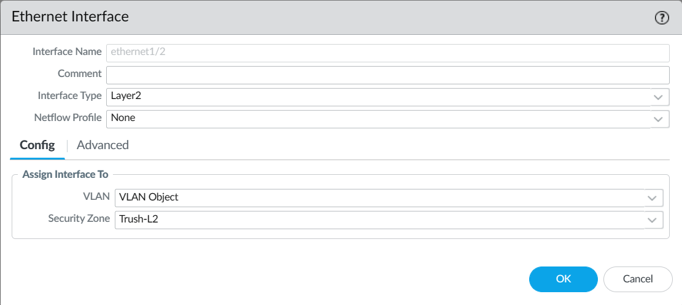

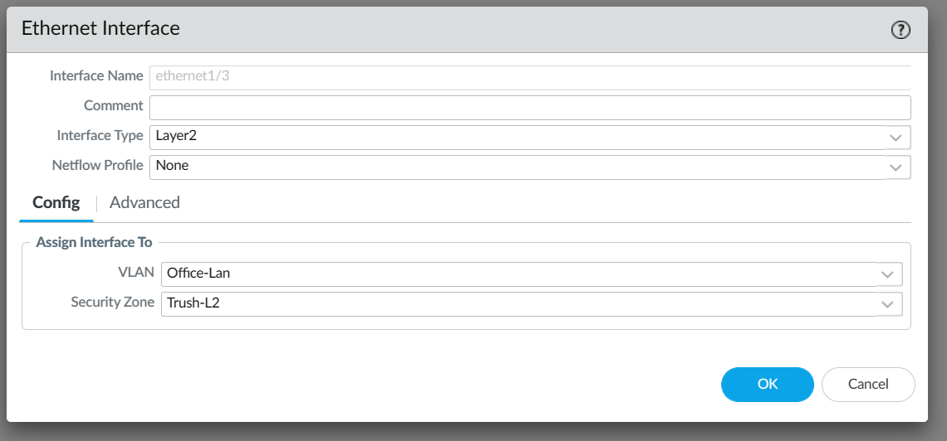

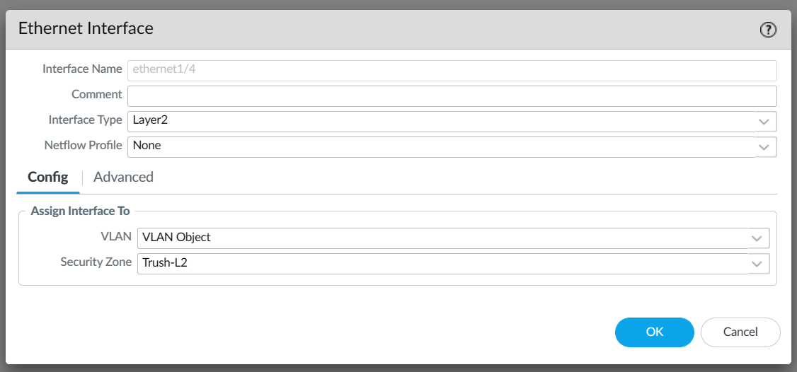

Exit, click vlan, create a vlan, the name is arbitrary. exit and click on Ethernet, click on 3 different interfaces, set the vlan to the vlan just created, and set the security zone to the only one in layer 2 set before

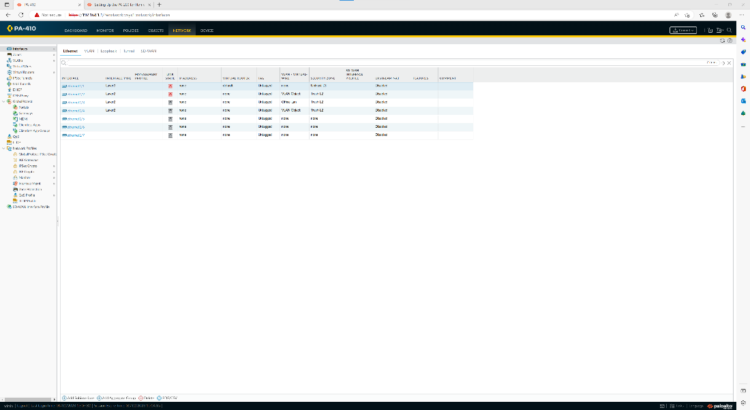

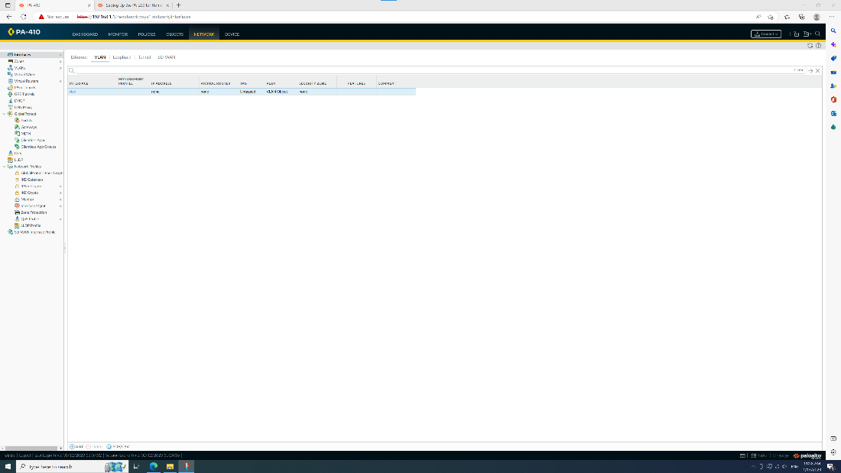

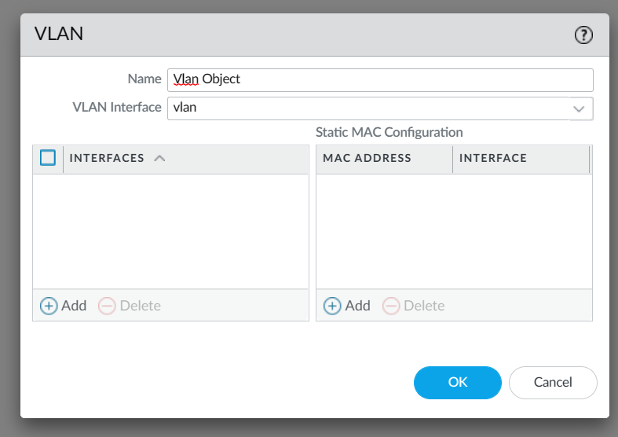

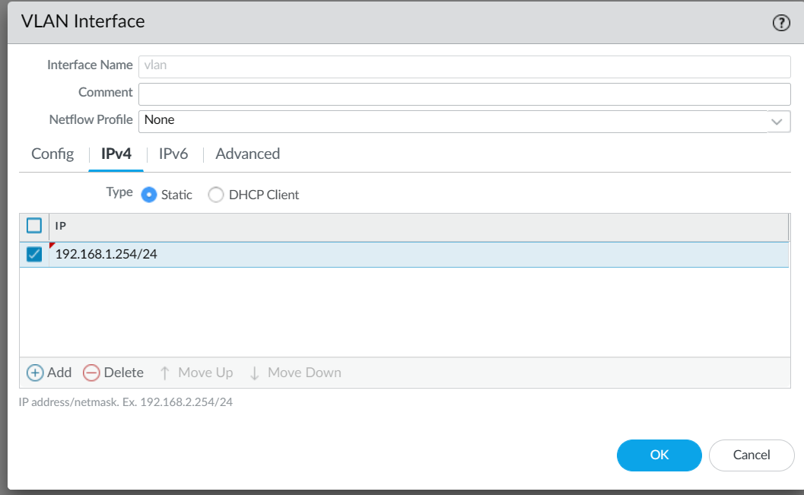

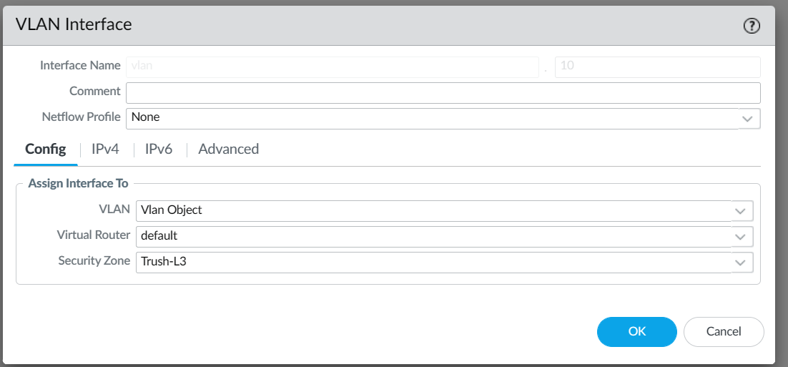

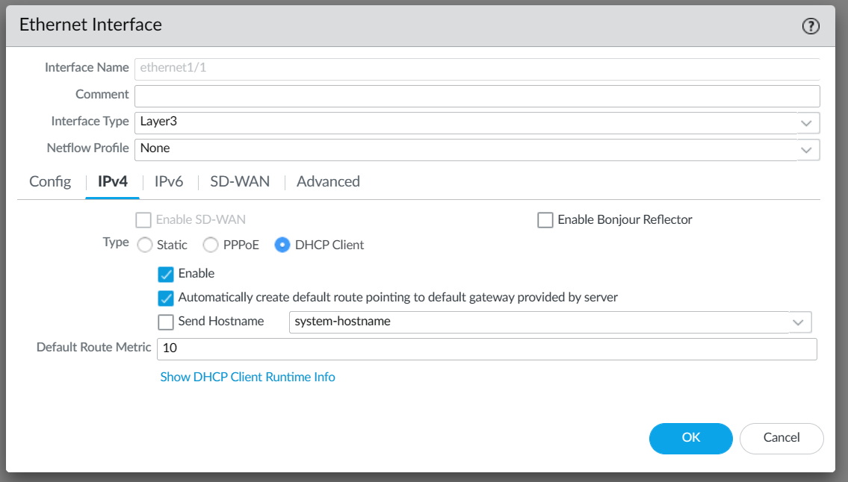

exit, click dhcp, add a dhcp server, then add the ip pool which is currently subnet, gateway and subnet mask, Add first and second dns to 8.8.8.8 and 8.8.4.4 respectively

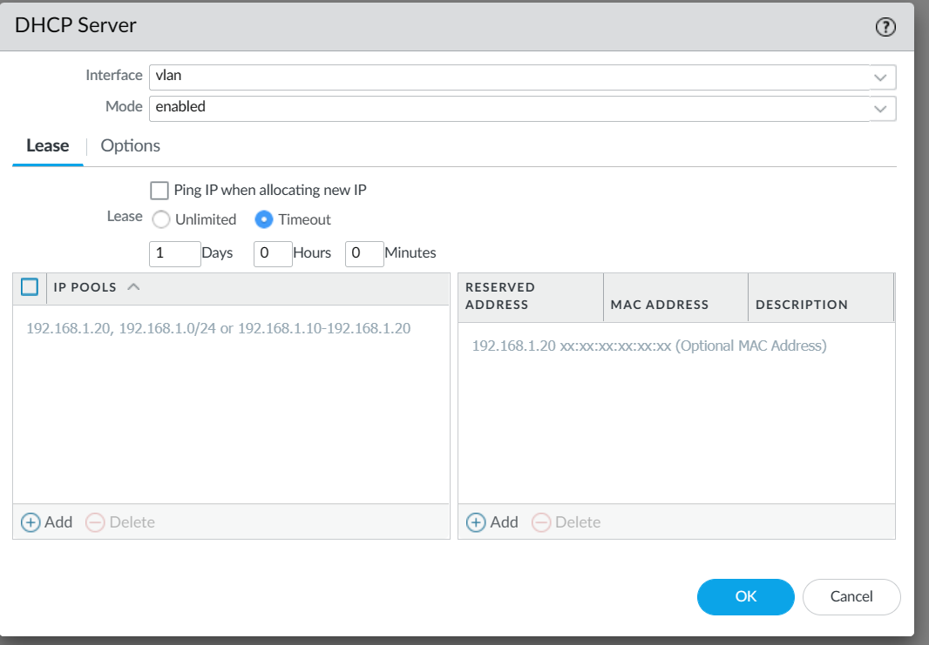

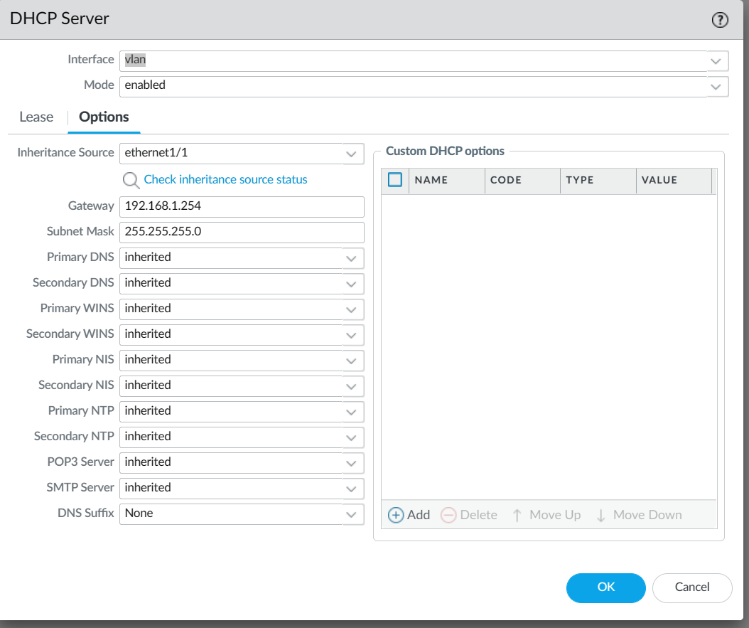

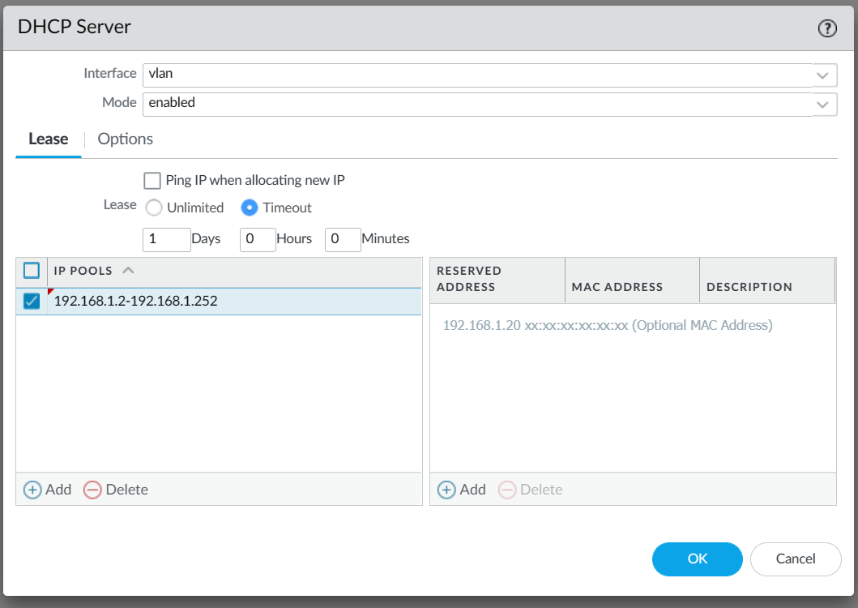

exit, enter object, click Security Profile Groups and add one,

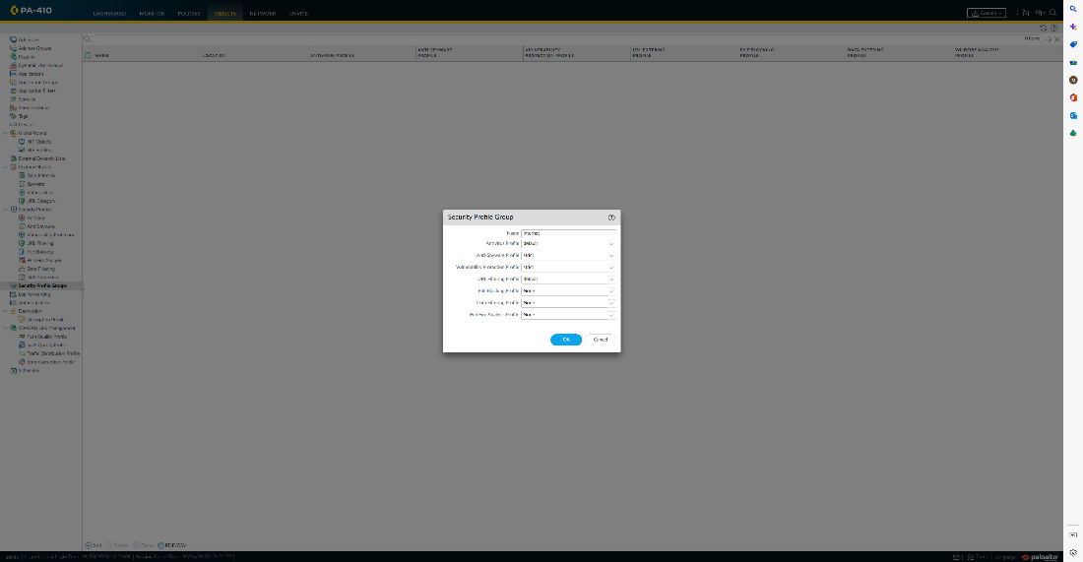

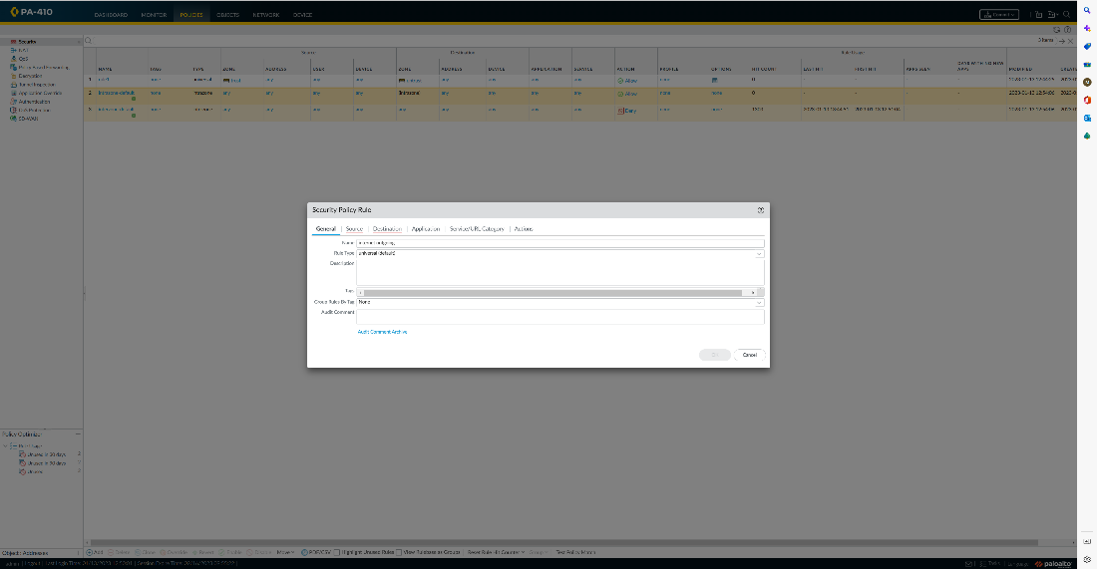

Exit, enter policies and add one security policy rule

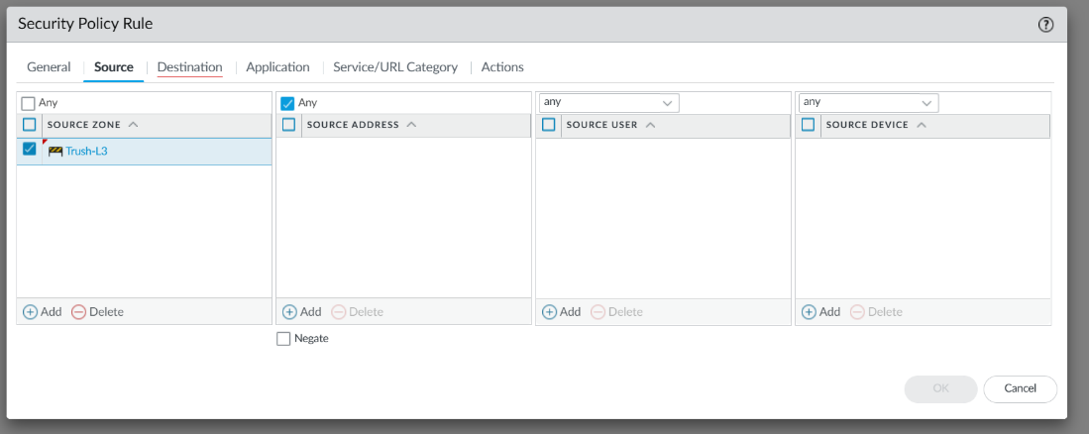

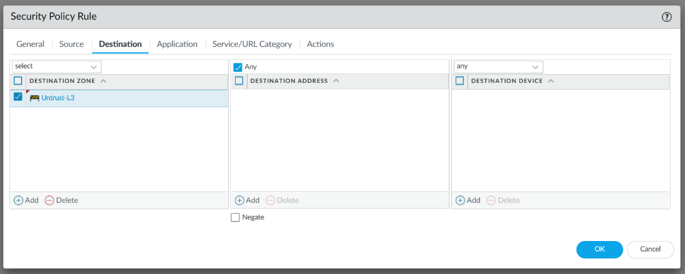

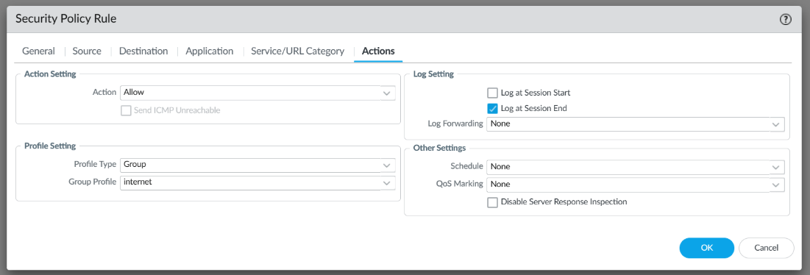

exit and add a NAT, click original packet, add a source zone which is that trust zone in layer 3, set the source to untrust layer 3, destination interface is outside to the internet interface

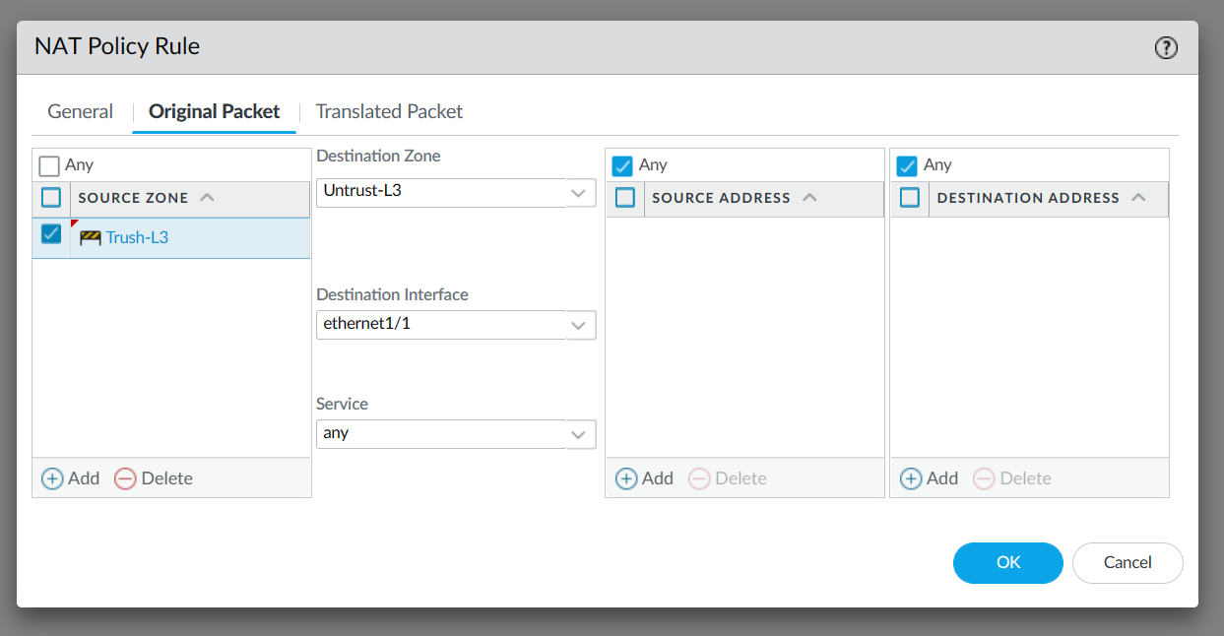

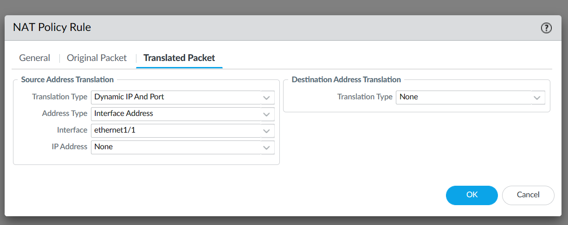

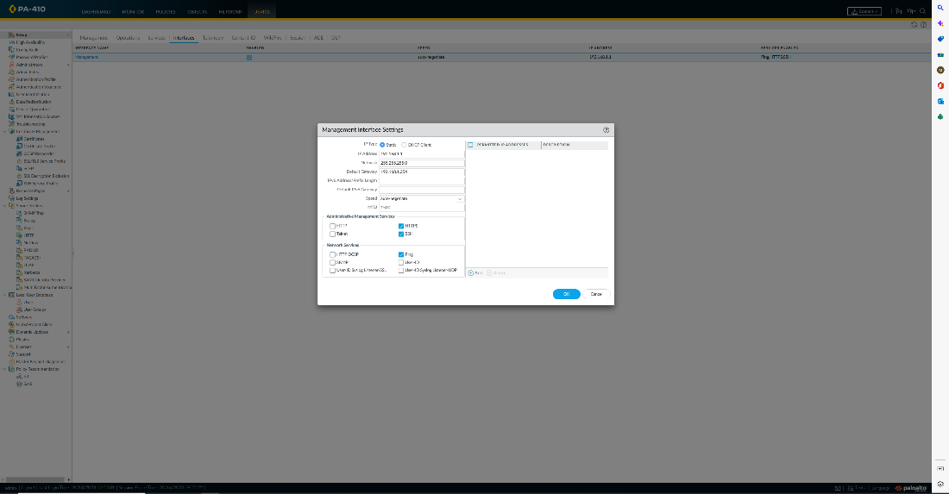

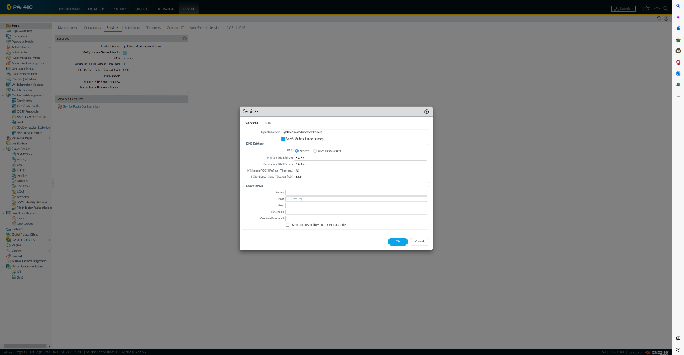

Set management interface:



Set service feature:



Commit the changing

Some screenshot: update license and access to website without connect to wireless network

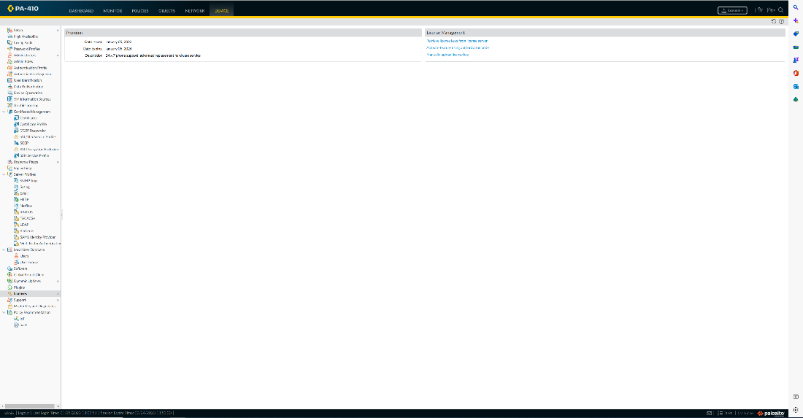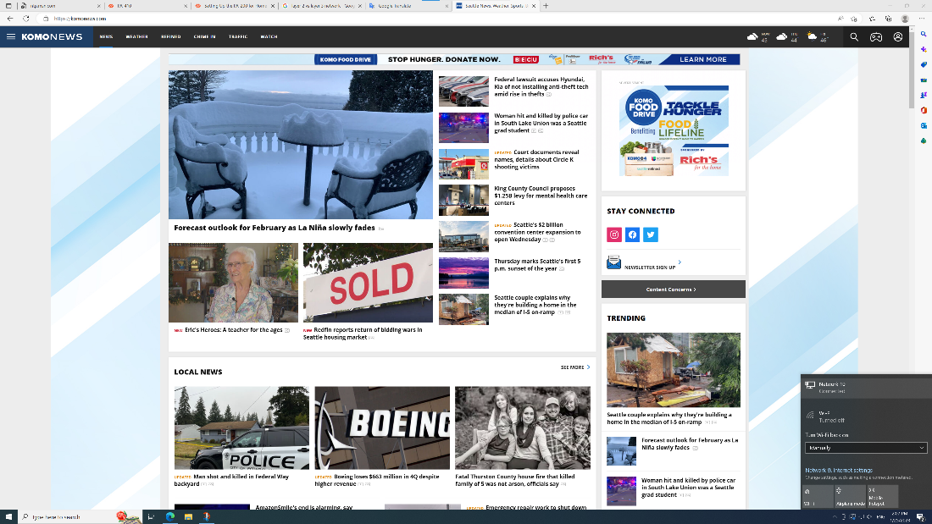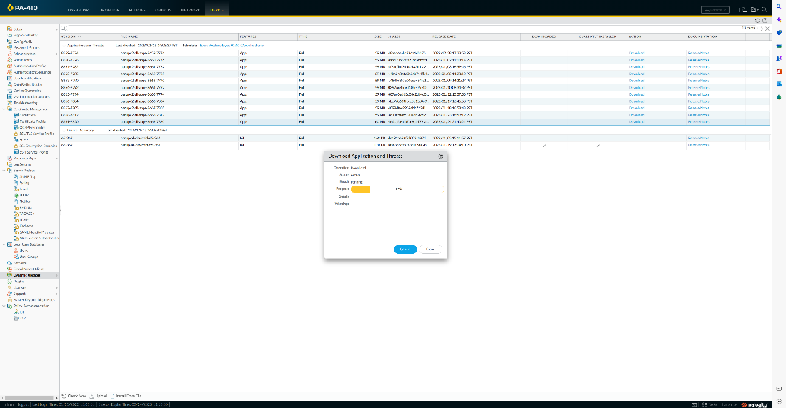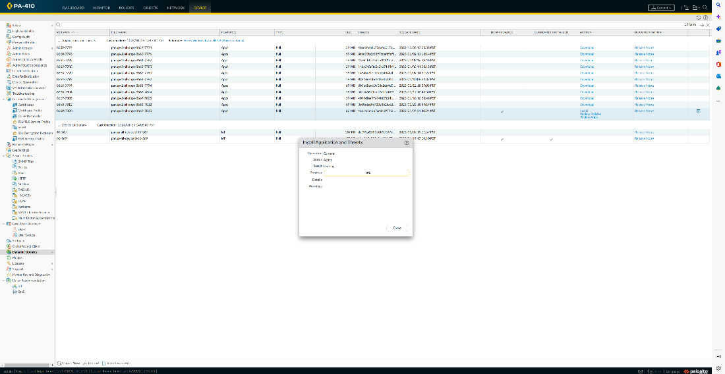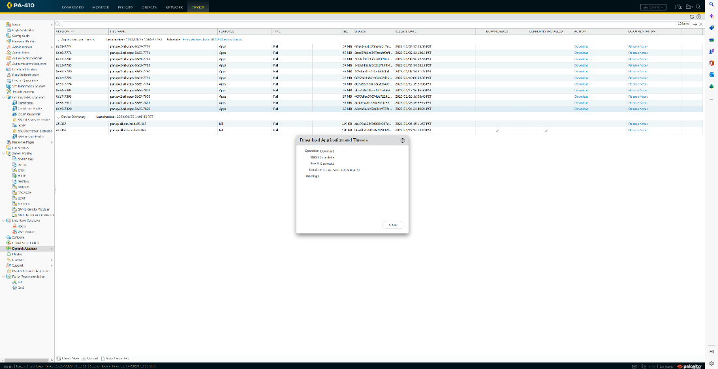

Problem:

Port 1/1 is not working because dhcp is signed on the wrong port, it is vlan.10 instead of vlan, can’t change it in config, it can only be deleted and added again

Everything works fine, but can't open the webpage, because that switch does not have portfast, just change it and it be fine

Lab 8

Create a site-to-site vpn using PSK

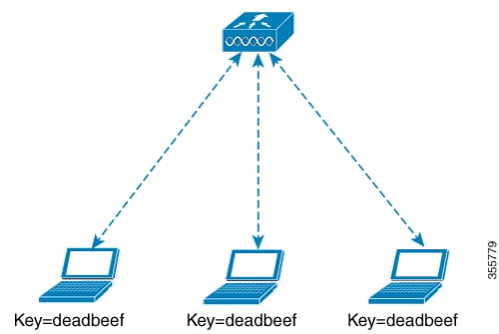

Using 2 palo alto firewall build a site-to-site VPN

Background:

A site-to-site virtual private network (VPN) refers to a connection set up between multiple networks. This could be a corporate network where multiple offices work in conjunction with each other or a branch office network with a central office and multiple branch locations.

Site-to-site VPNs are useful for companies that prioritize private, protected traffic and are particularly helpful for organizations with more than one office spread out over large geographical locations. These businesses often have to access resources housed on a primary network, which could include servers that facilitate email or store data. In some instances, a server may be the operational hub of an application essential to the company’s business. A site-to-site VPN can, in that case, give all sites full access to the application—as if it were housed within their physical facility.

Advantages:

Provides a secure connection between two or more networks.

Enables users to access resources located in another location or office.

Encrypts traffic between networks to enhance security.

Offers a cost-effective solution for interconnecting networks.

Provides a high level of network performance and reliability.

Both Site to site VPN and Remote access VPN are the types of VPN which stands for Virtual Private Network. Site-to-Site VPN is also known as Router-to-Router VPN. In site-to-site VPN, IPsec security method is used to create an encrypted tunnel from one customer network to remote site of the customer. Multiple users are not allowed in Site-to-Site VPN.

Diagram:

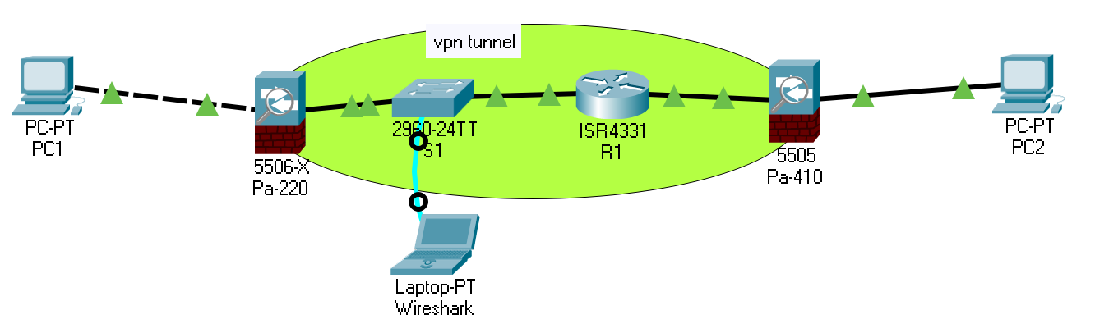

Steps:

*Firewall on both sides have the same configuration, just change ip address from 10.1.2.x to 10.1.1.x and 200.1.1.x to 100.1.1.x, this is configuration of pa-410, pc address can be any

**switch not need to config

Create 3 different zones, all of them are layer 3

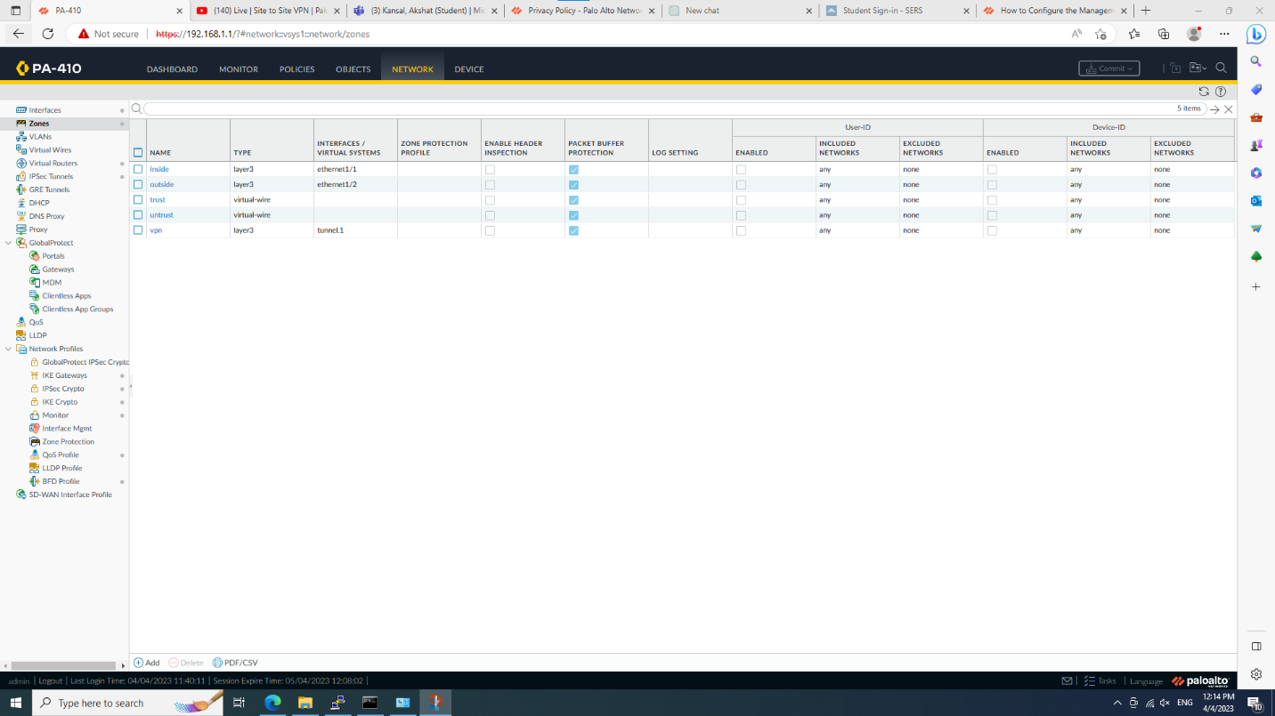

Config ethernet 1/1 and ½, assign layer 3 and ip address both inside and outside

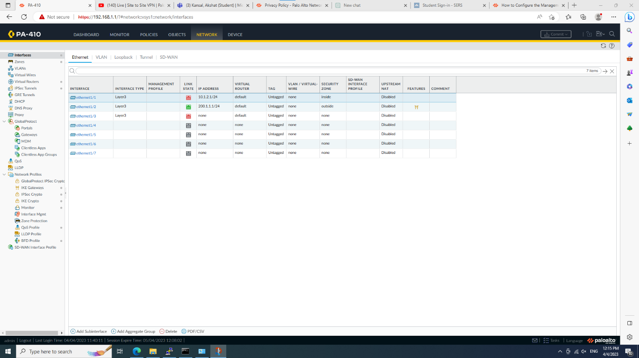

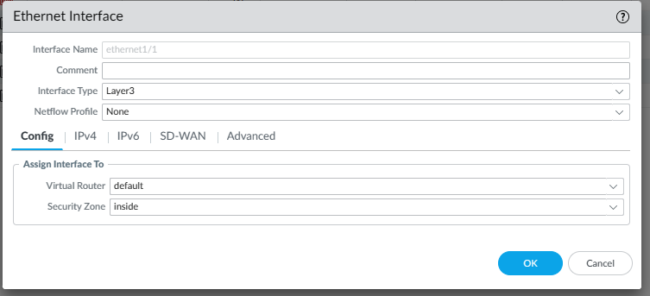

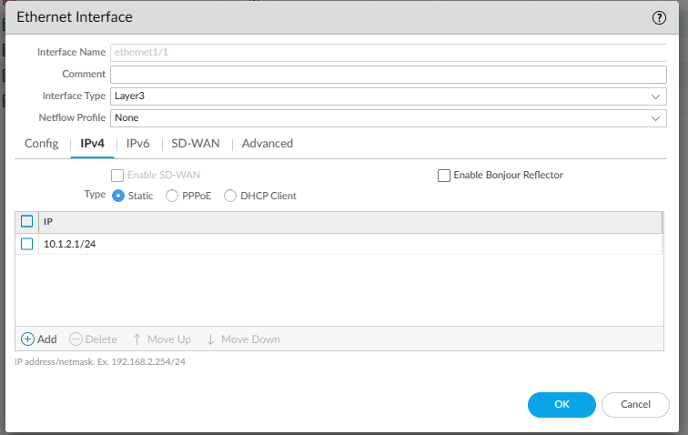

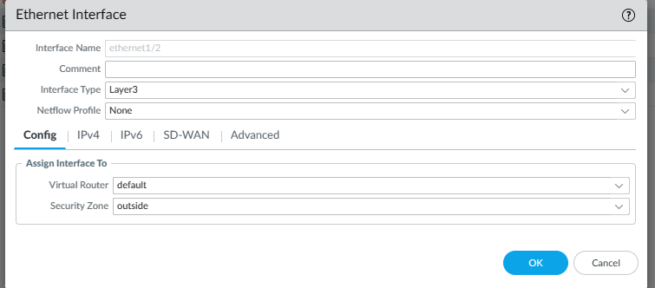

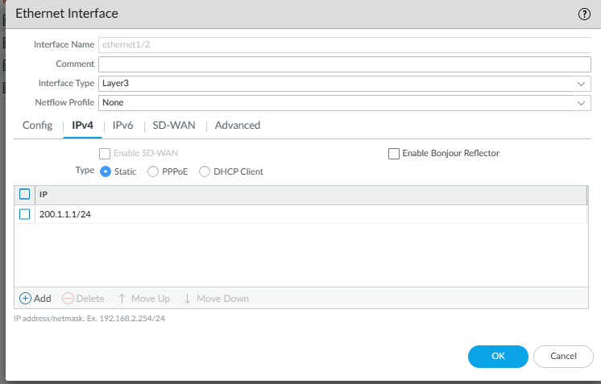

Config vpn tunnel interface and a unique ip address other than 10.1. and 200.1.

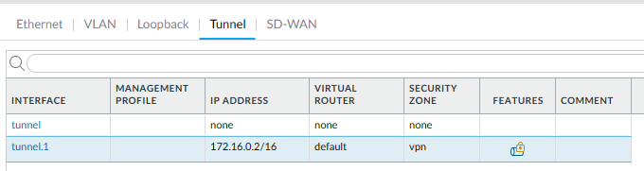

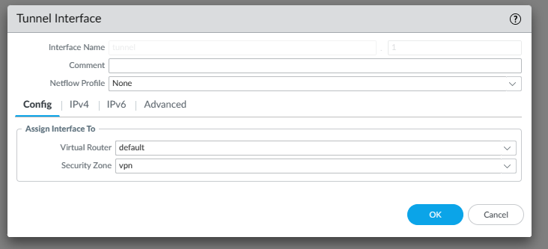

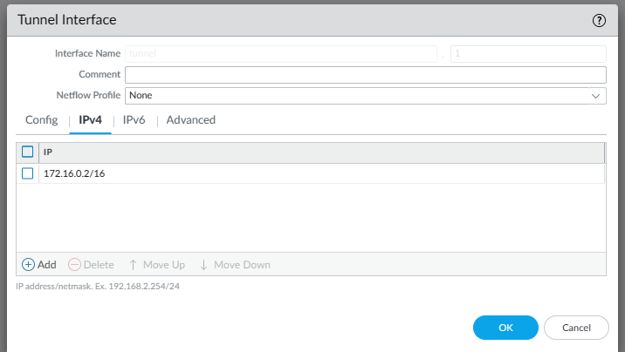

Config virtual router, br2 on pa220 should have a destination of 10.1.2.0/24 and a next hop of 172.16.0.2, default route just change 200 to 100

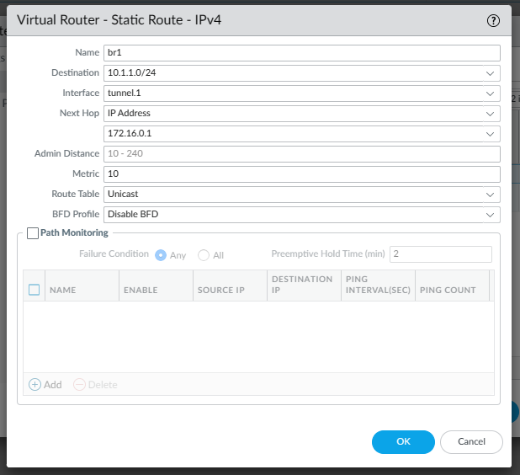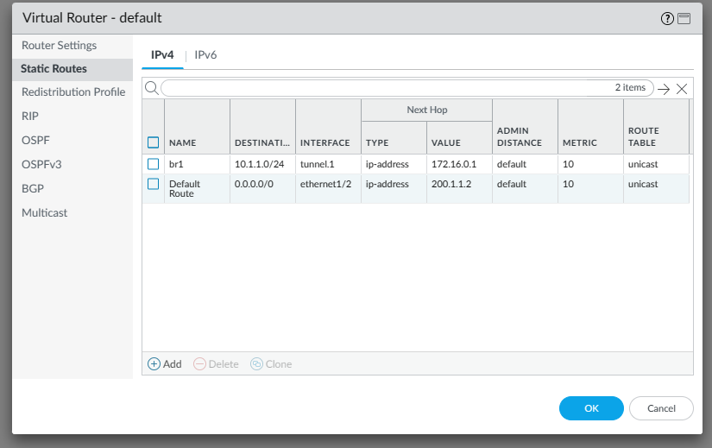

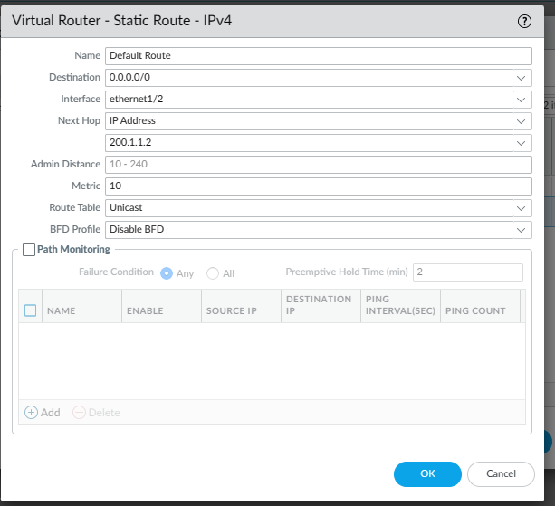

Create a IPSec Tunnel, it should be on below of virtual router on left column

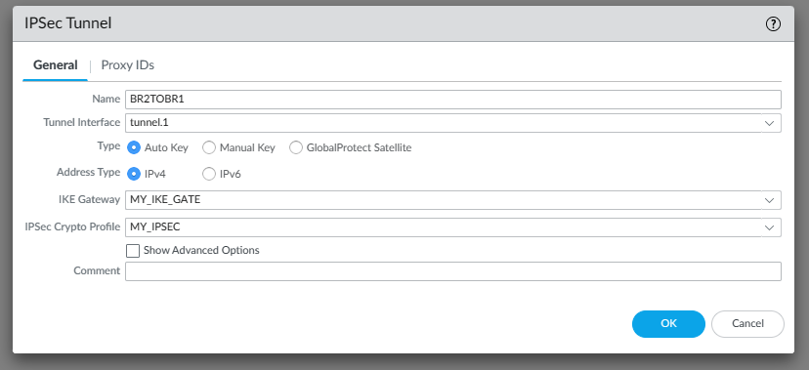

Add a IKE gateway, make sure PSK on both are the same, otherwise it won’t work

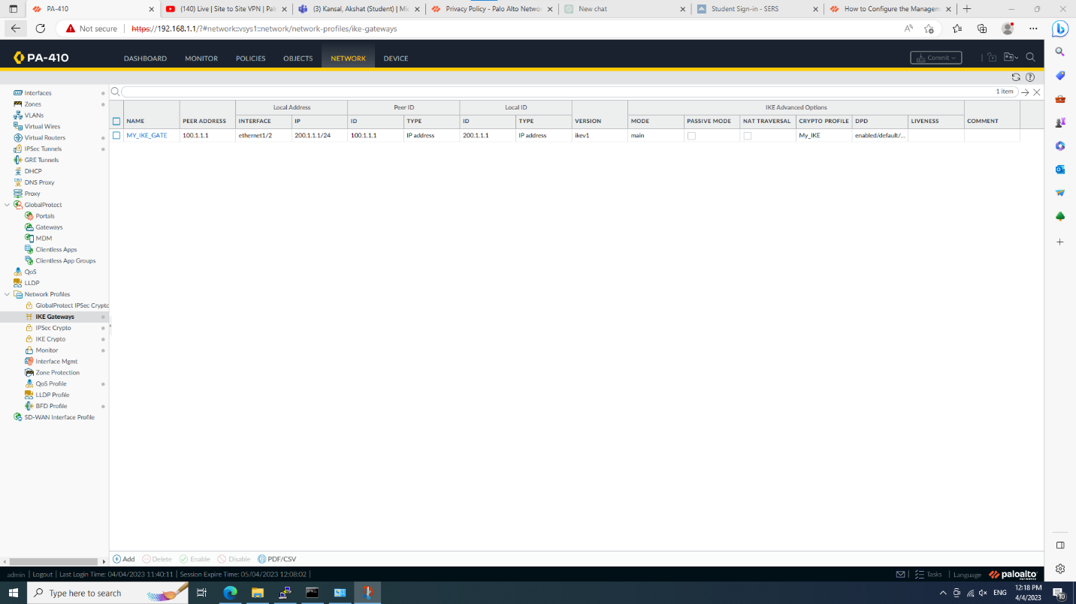

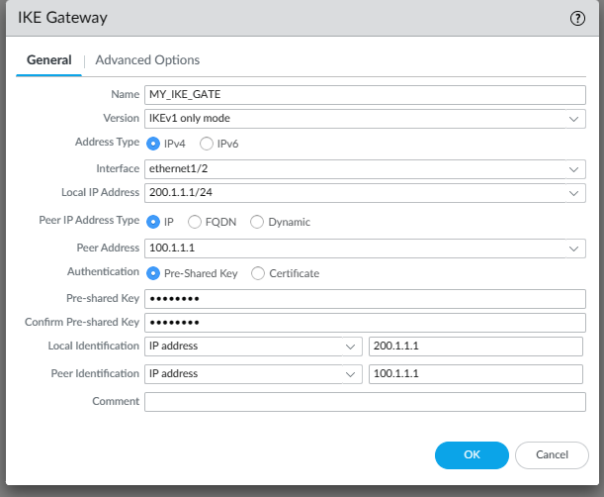

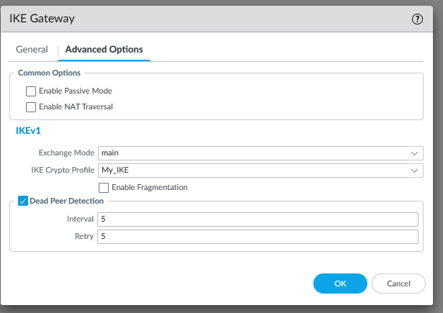

Create a IPsec crypto

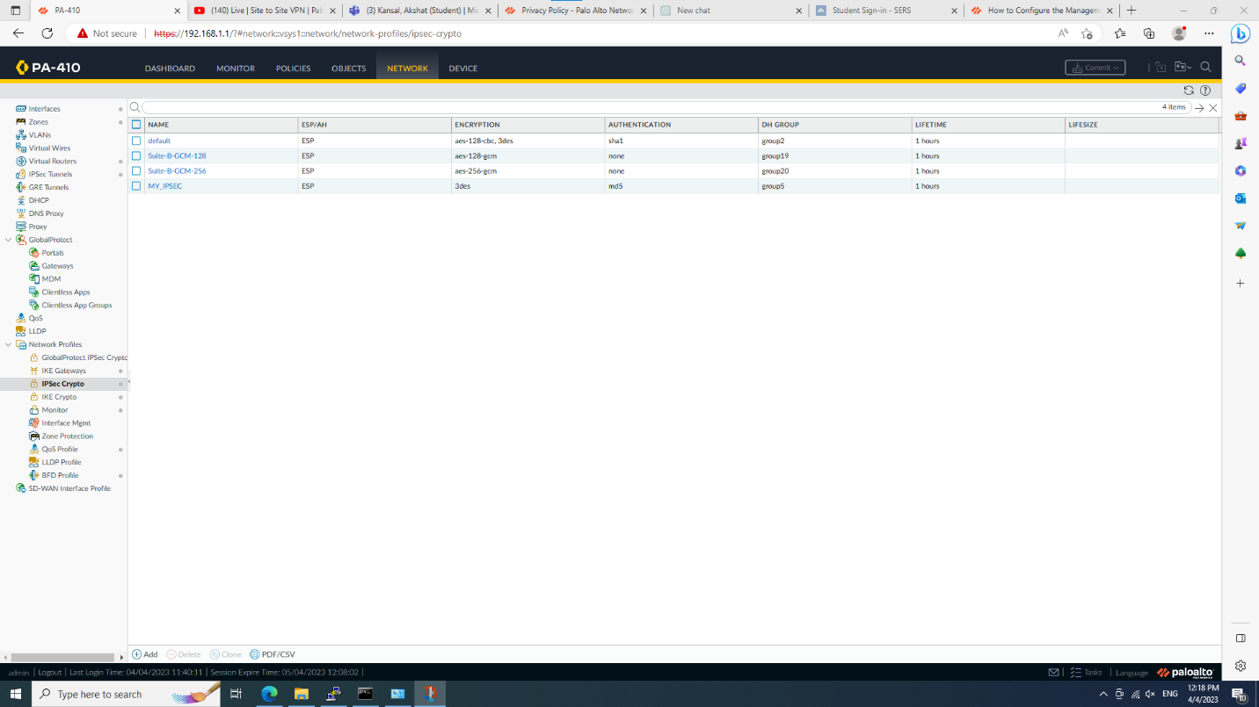

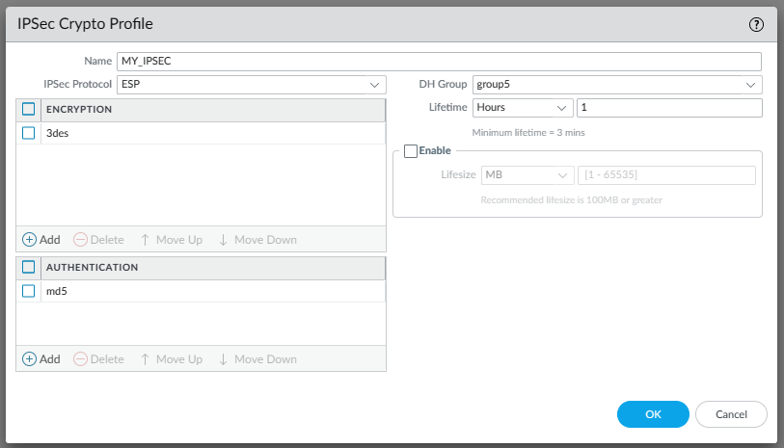

Create IKE crypto profile

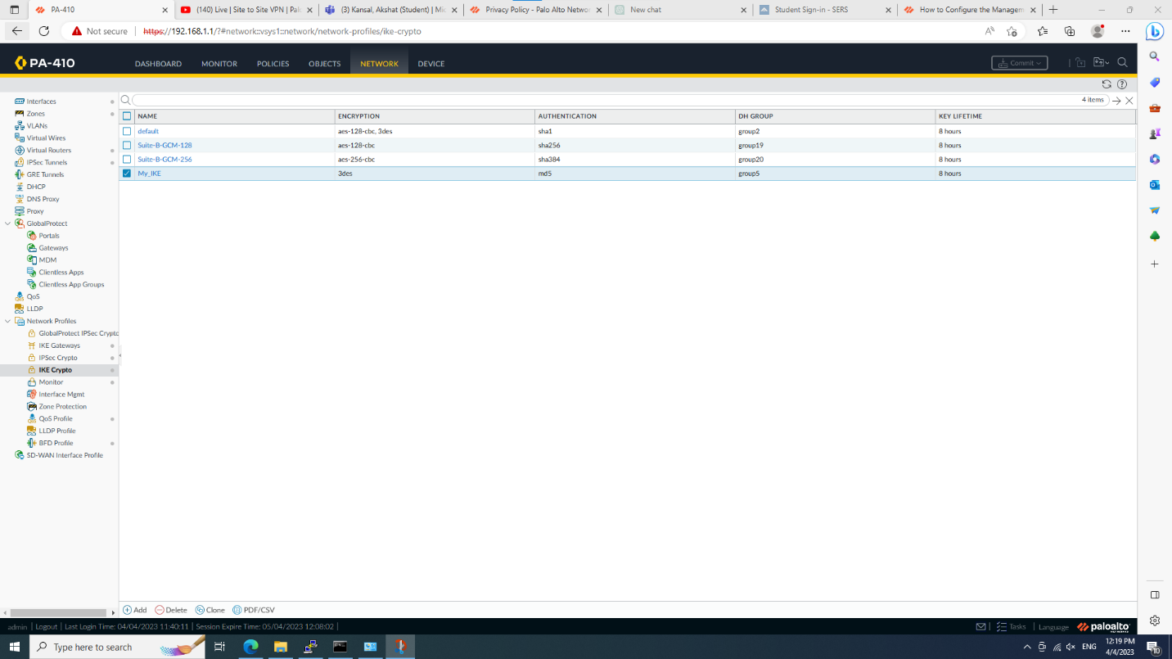

Active router port which in the middle and set ip address

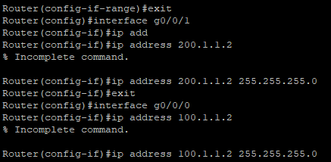

Type these 2 commands on both firewall console:

test vpn ipsec-sa

test vpn ike-sa

Final result

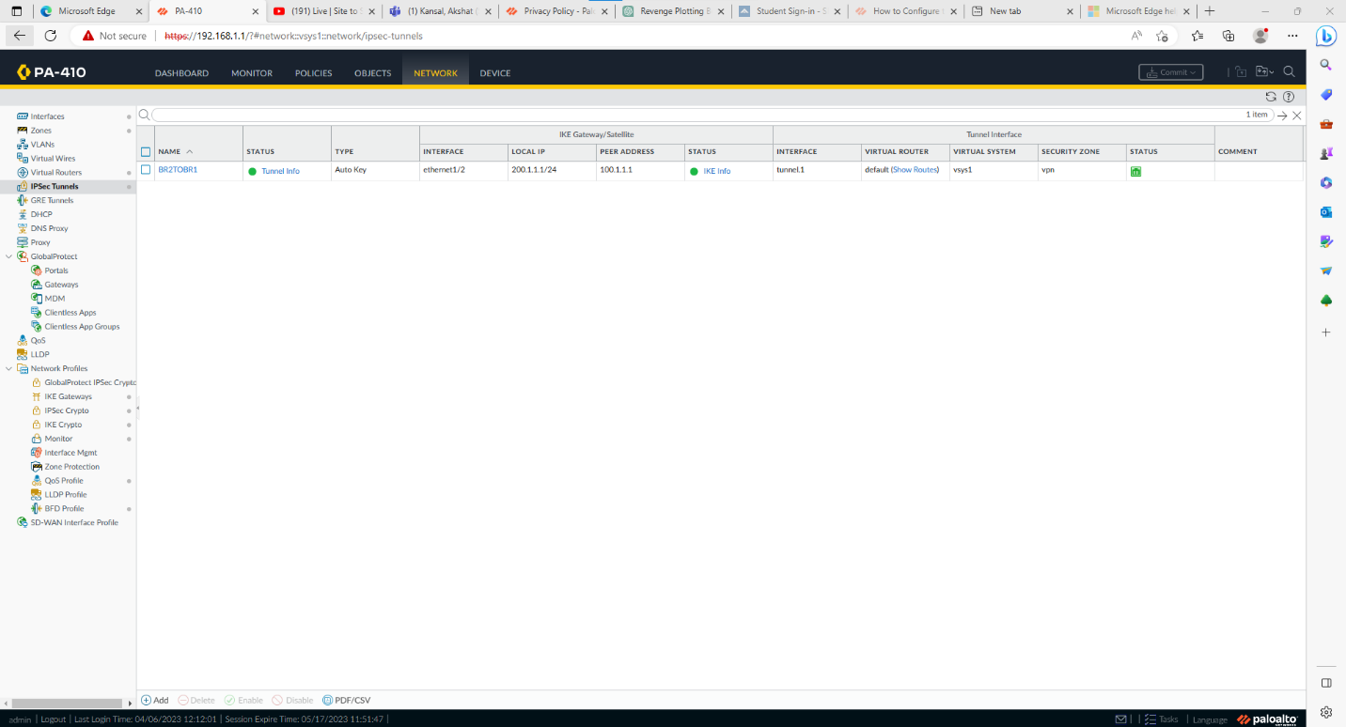

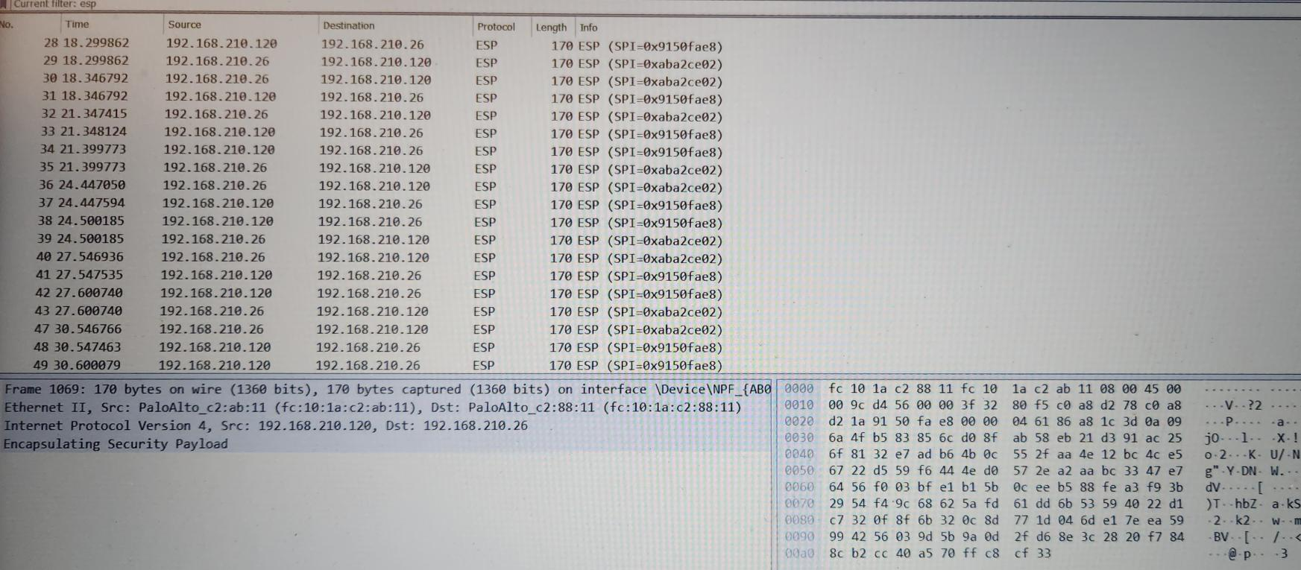

Problem:

Since our own rack was occupied, we had to find another rack and borrow someone else's firewall (sort of)

The PSK at both firewall must be consistent, otherwise the vpn will not work. Sometimes when the PSK is modified, it will instantly bounce back to the original one, but it will work again the next day. I am not sure what caused this.

These two commands on the two firewalls must be entered, otherwise the vpn tunnel will also display red, but tutorial video does not mention it

Lab 8

Create a site to site vpn using certificate

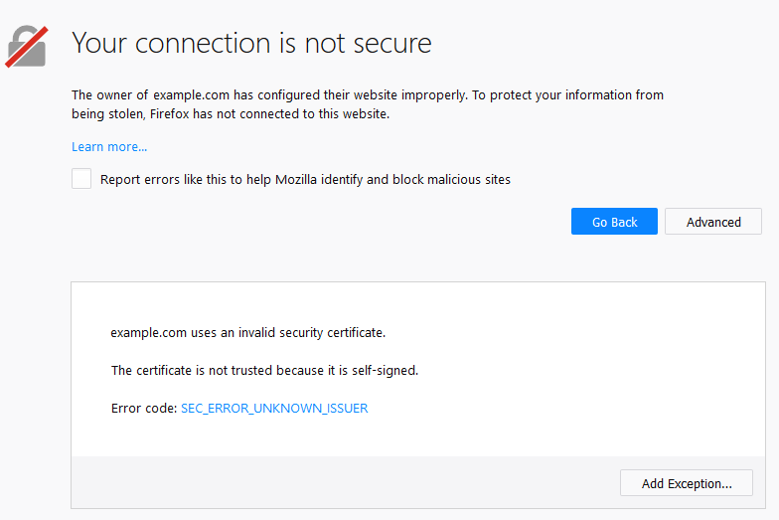

Using 2 palo alto firewall and self signed certificate to build a site-to-site VPN

Background:

Site-to-site VPN is a connection established between multiple subnets. Under normal circumstances, site-to-site VPN is a protection strategy for long-distance transmission of encrypted transmission. In this channel, data will be encrypted, so that wireshark can only observe To a mess, but site-to-site is also used in some companies, such as the company's main server is not nearby, but must be accessed due to certain circumstances, which allows one site to gain access to another site

Both site-to-site and remote access VPNs are used for long-distance encrypted transmission. In site-to-site VPN, an encrypted tunnel is created between the two ports. There cannot be users other than the two ports in the middle. In remote access VPN, then Multiple users are connected to an encrypted private network. In this private network, network connections can be established and accessed anywhere, but users cannot interact with each other.

PSK vs self-signed certificate.

The biggest difference between using PSK and self sign certificates is that PSK allows the ports on both sides to use the same password to ensure mutual trust, while self sign certificates use the same certificate. Obviously, in PSKlab, the time consumed is significantly longer than that of self sign certificates , this is because PSK has too many basic settings that need to be set up, including virtual routers, zones, etc. Conversely, in self signed certificates, you only need to copy the certificate of one port to another port, and then do some port and certificate Additional configuration, and then install the certificate on the client. Inevitably, self signed certificates also have some defects, such as certificates will expire, and PSK can be used all the time as long as it is set up, and if the client is far away, installation is very troublesome. I have to say, on the other hand, PSK If the password is leaked, it needs to be discovered and corrected in time, but self sign certificates do not have this problem, because if the certificate is not installed on the client, it cannot be connected

overall, compared with these two encryption methods, PSK certificates are more universal, while self signed certificates are proprietary

Diagrams:

Step:

Create a new certificate on the starting point

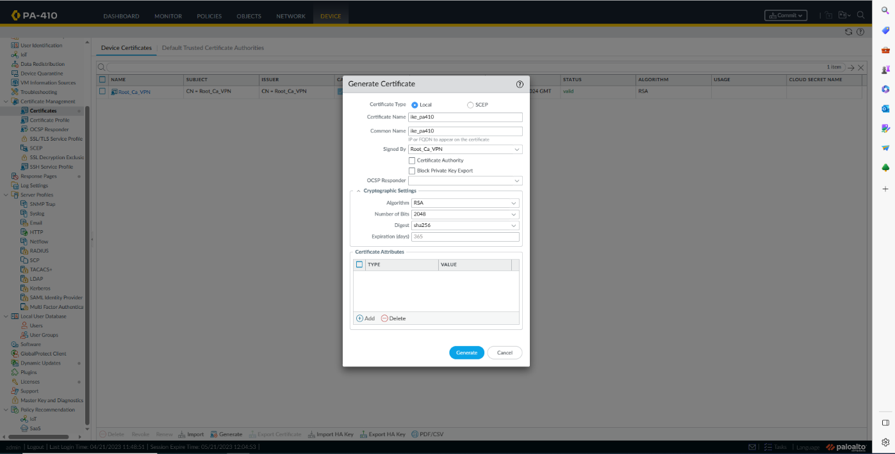

And a certificate profile

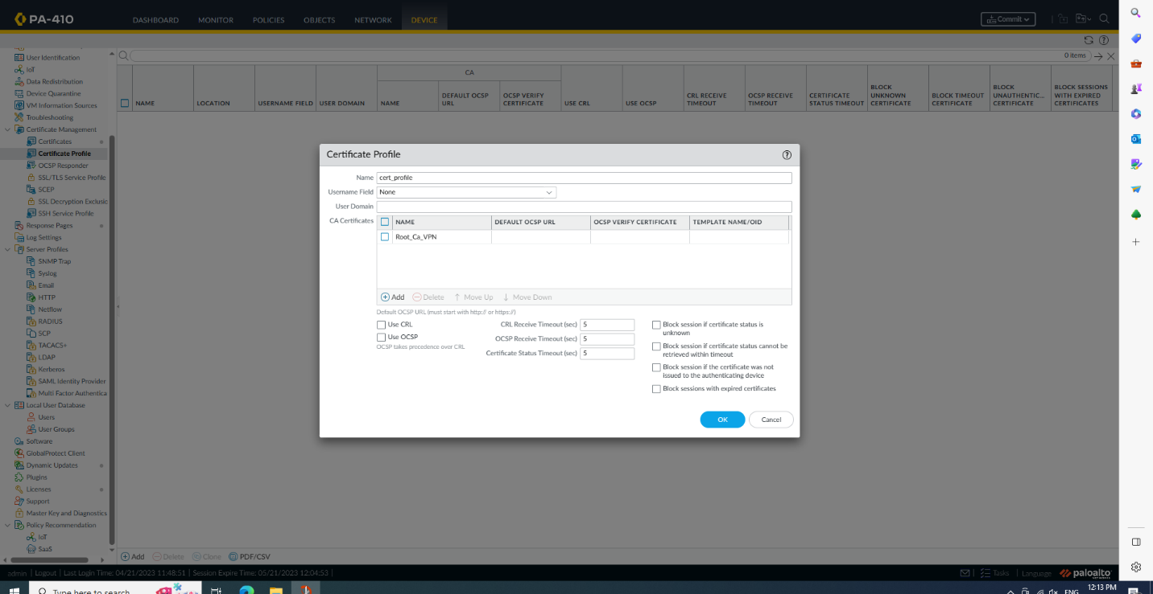

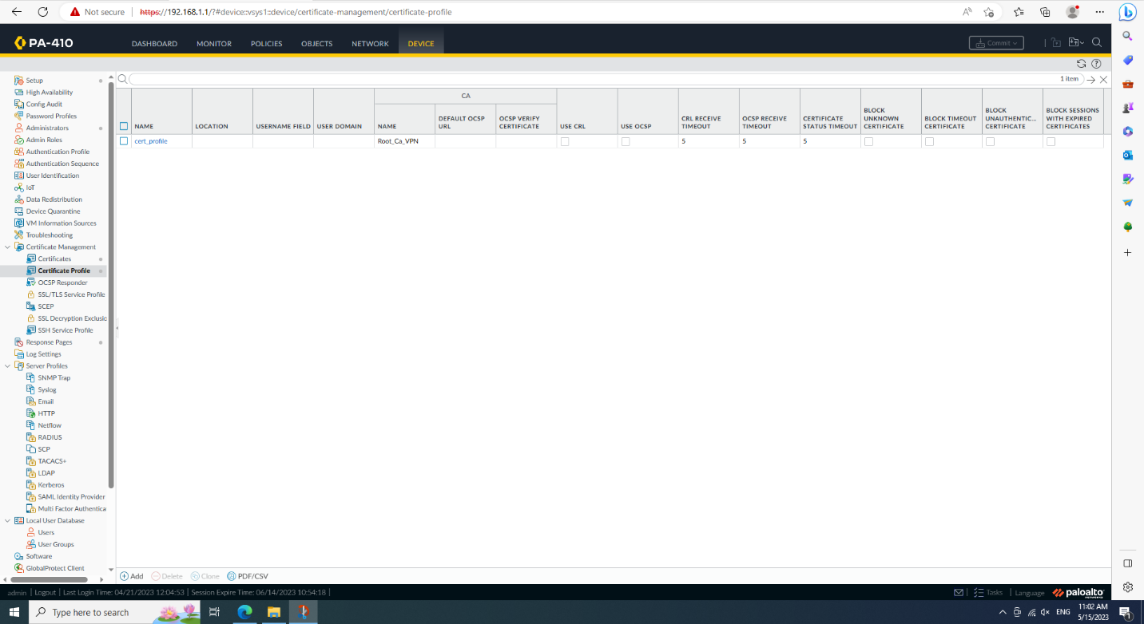

Create a new IKE gateway.

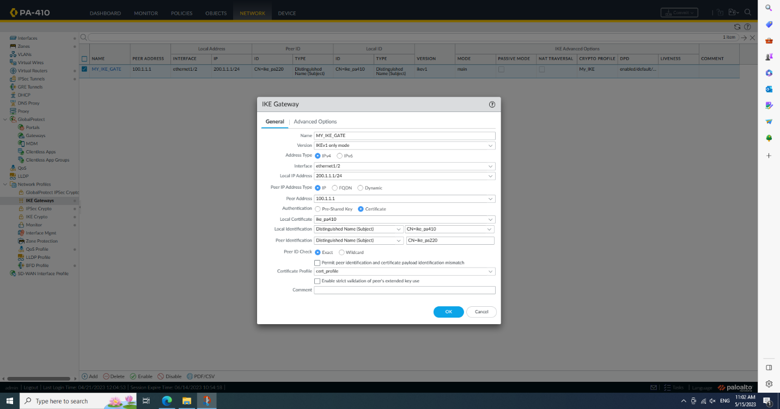

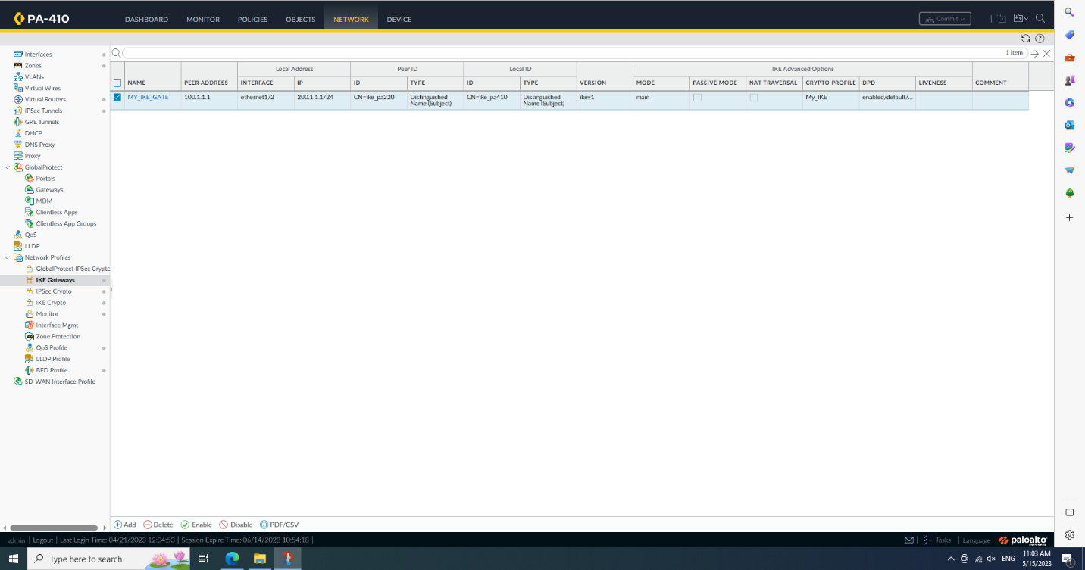

Export the certificate.

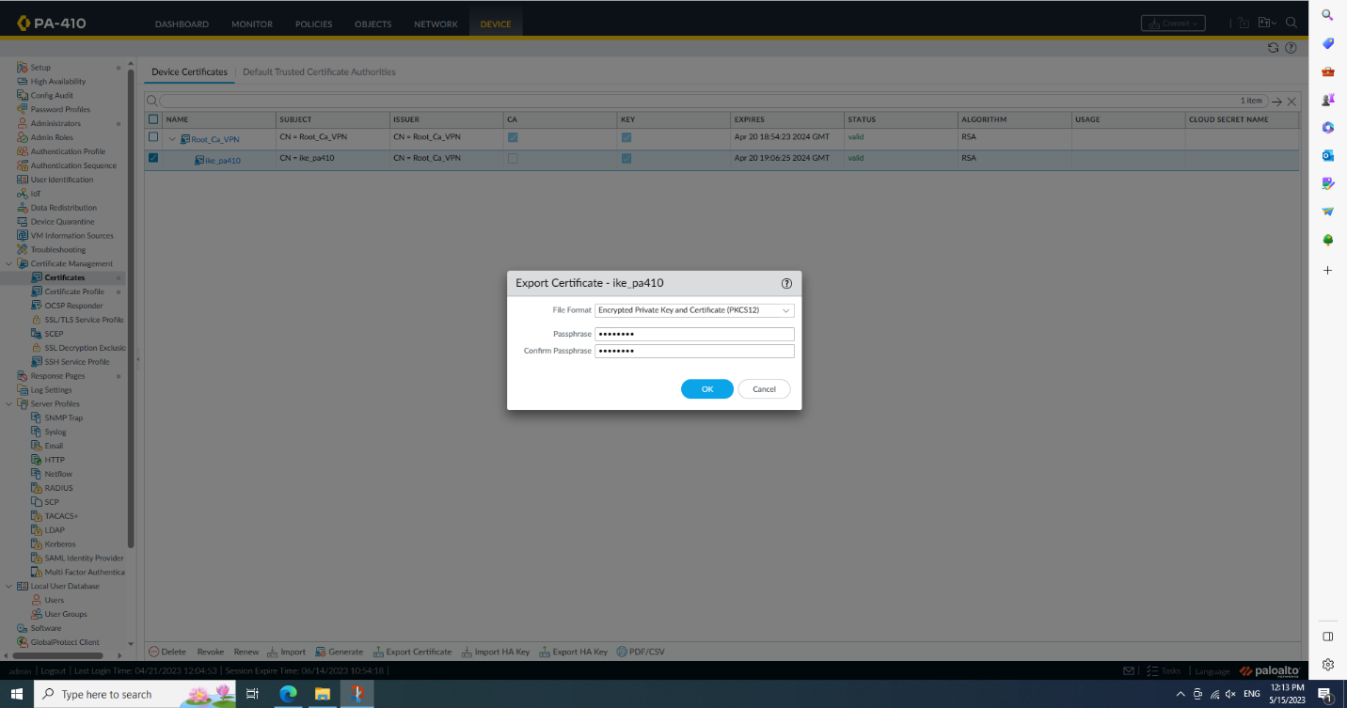

Import on other side firewall.

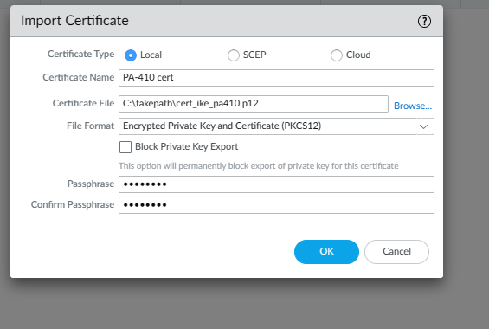

Create certificate profile on pa-220

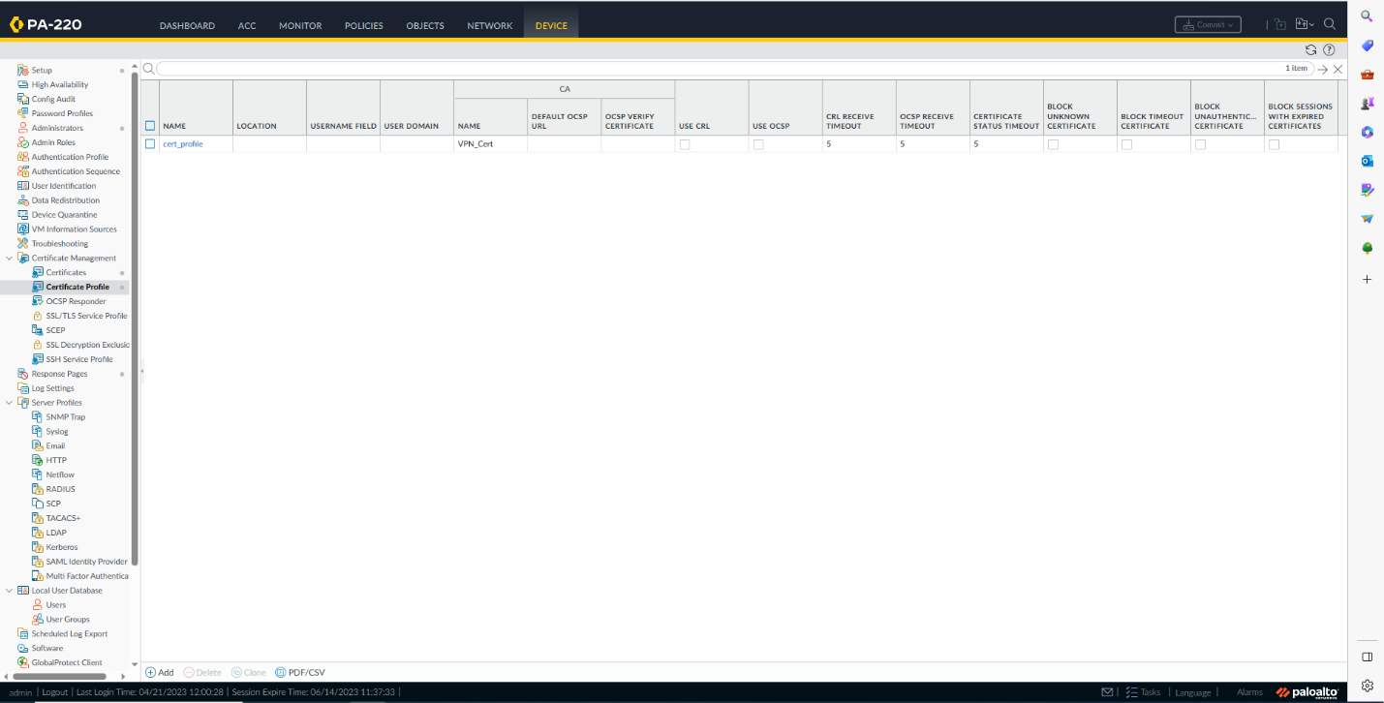

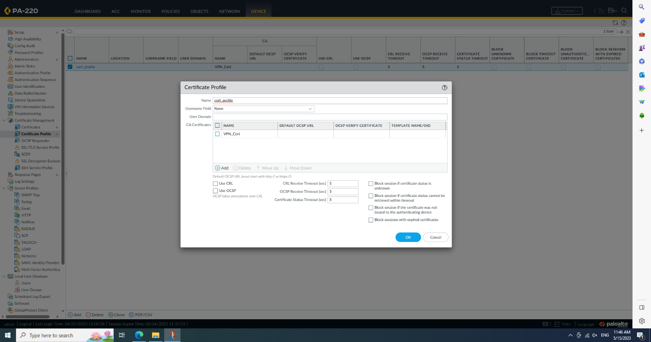

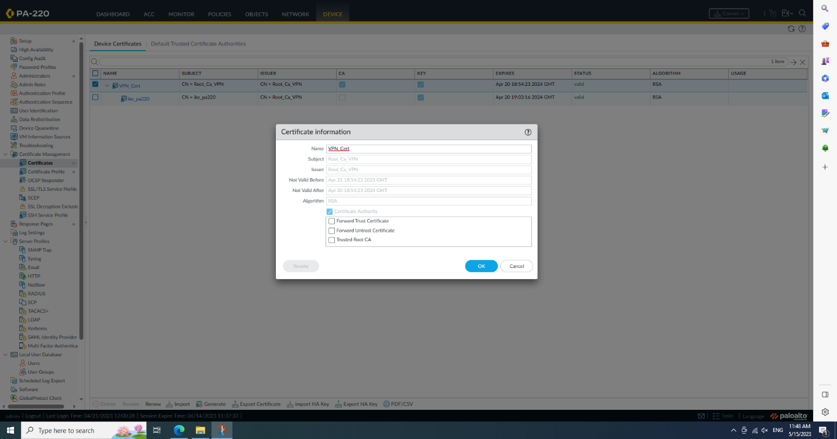

Install the certificate on the client

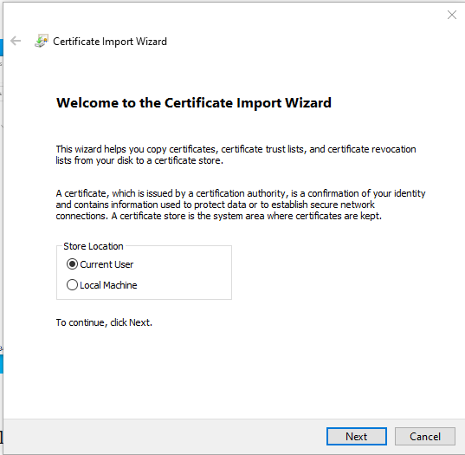

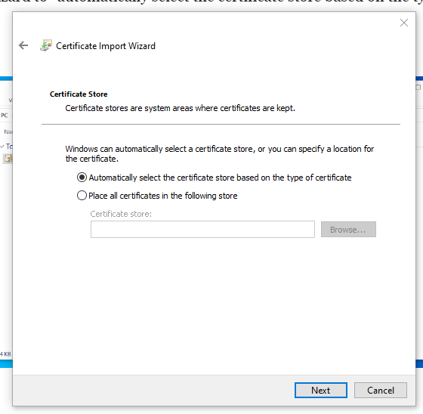

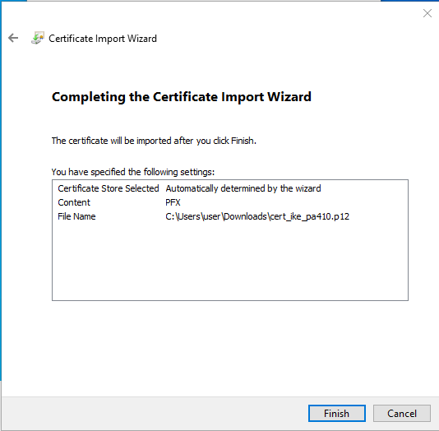  
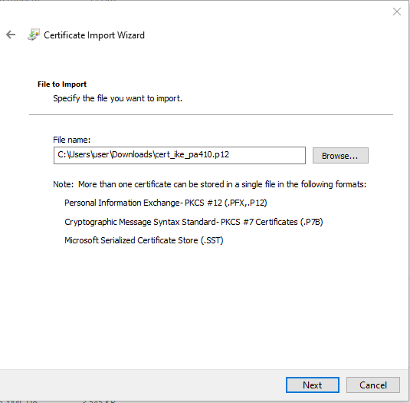

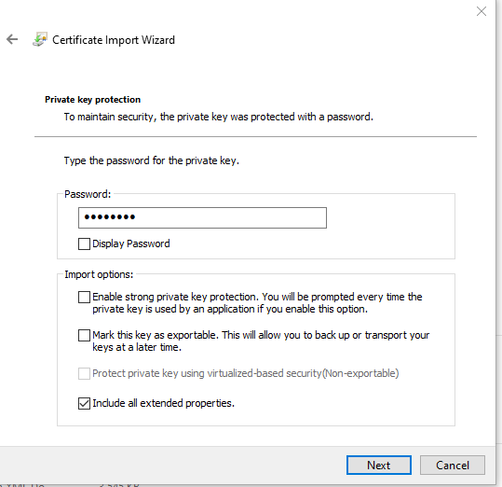

Open mmc(Microsoft Management Console)

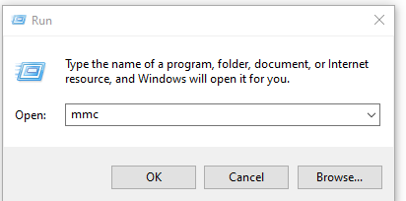

Snap in the certificate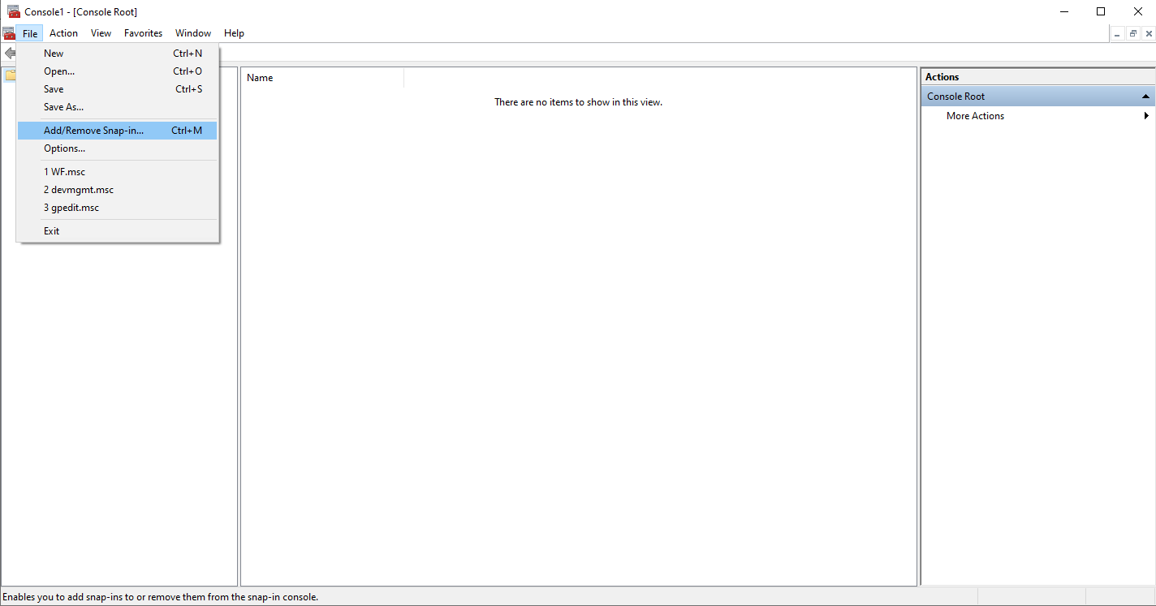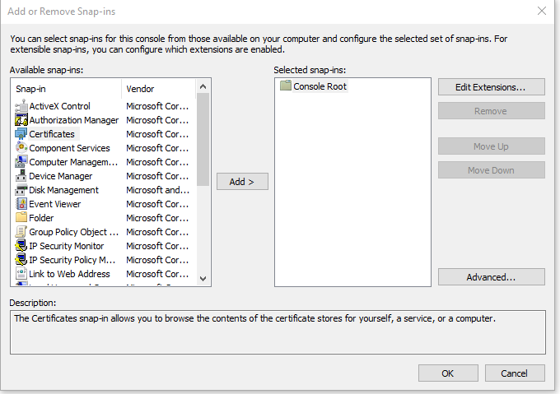

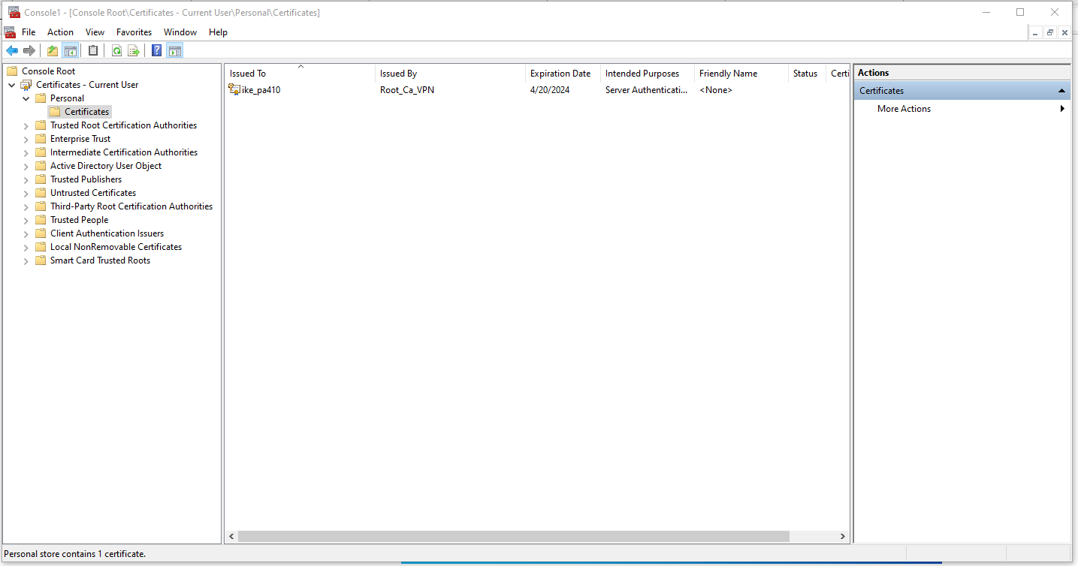

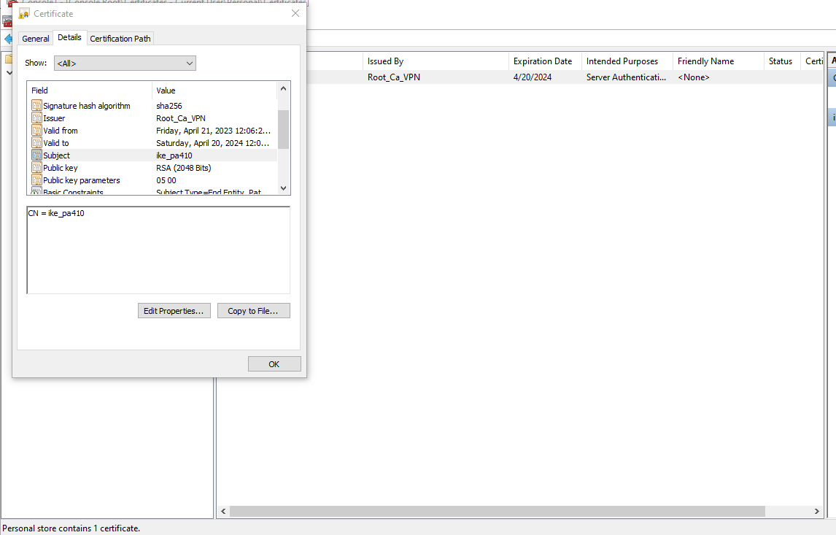

Problem:

I haven’t met any problem in this lab

Conclusion:

Obviously, a site-to-site vpn using a certificate can be set up very quickly compared to a vpn using a PSK, but it not only expires, but also needs to be installed on each client,

Lab 9

Set up remote access vpn using cert

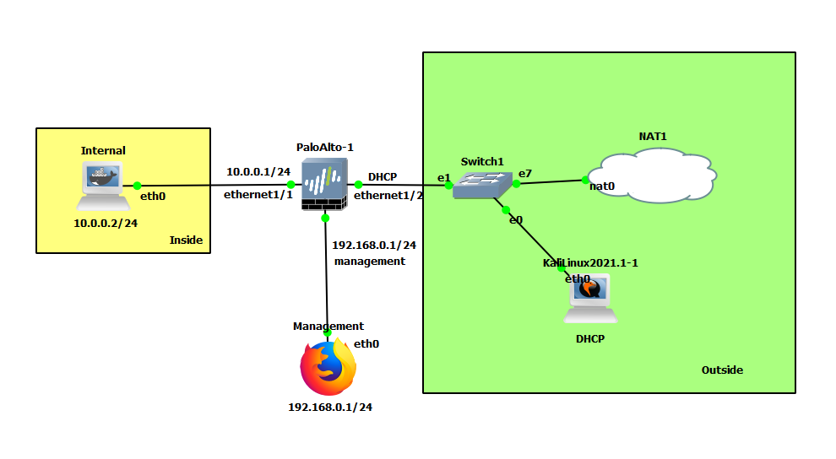

Remote access VPN using self-signed cert

Background:

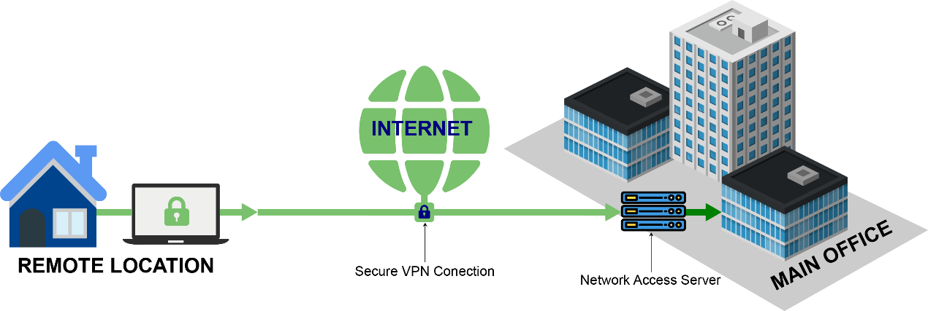

Remote access vpn is a way to connect from a personal port to a proprietary network, providing a dedicated tunnel encryption that makes it inaccessible to unauthorized users. Remote access has many uses, one of which is to enable authorized users to securely access the resources of a proprietary network even if they are thousands of miles apart. Unlike site-to-site, remote access vpn establishes encrypted tunnels directly from remote users, rather than between routers or firewalls, which may make the encryption easier to break, but also increases the area that is encrypted, and as long as the tunnel is established, it can be accessed securely at any time until it expires

On the other hand, remote access vpn is divided into ssl and self-signed certificate, relatively speaking, self-signed certificate is more amateurish because it is not issued by CA, so it may be identified as insecure, but it is fast, convenient and it is 100% free, in addition, ssl encryption is a certificate issued by CA, which helps to establish trust and authenticity, so it is more secure, it is worth mentioning that Although ssl encryption is free, but if you want CA to issue ssl certificate, you may need to charge

Both site-to-site and remote access VPNs are used for long-distance encrypted transmission. In site-to-site VPN, an encrypted tunnel is created between the two ports. There cannot be users other than the two ports in the middle. In remote access VPN, then Multiple users are connected to an encrypted private network. In this private network, network connections can be established and accessed anywhere, but users cannot interact with each other.

Diagram:

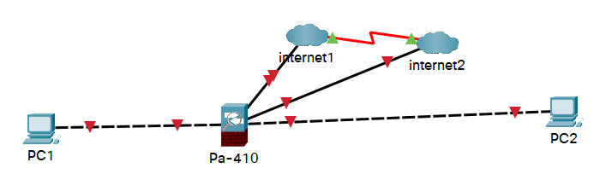

Steps:

Finish all the SOHO configuration on firewall, specific step can find in report of pa-220 and pa-410 set up

Generate a new root certificate

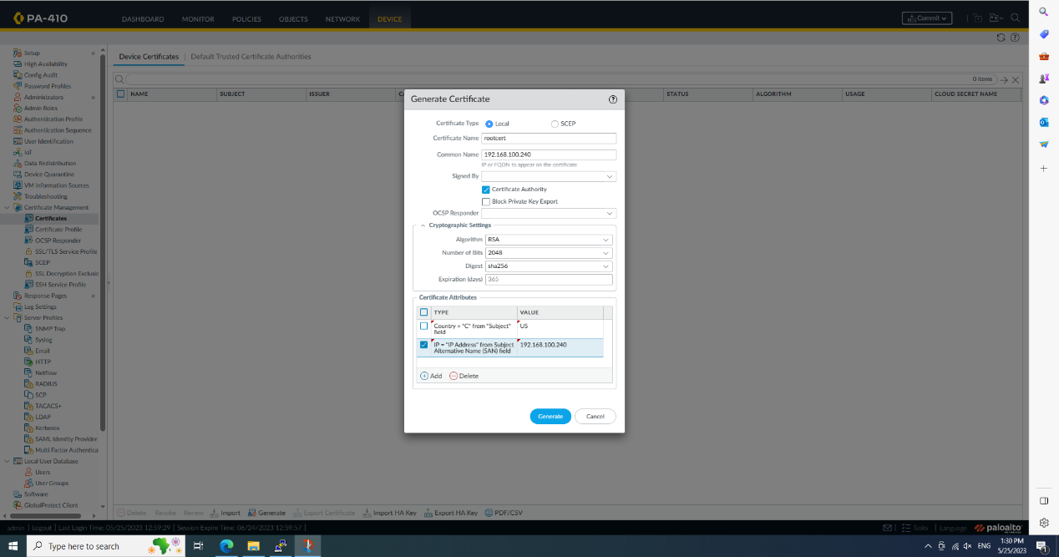

Create a ssl service profile

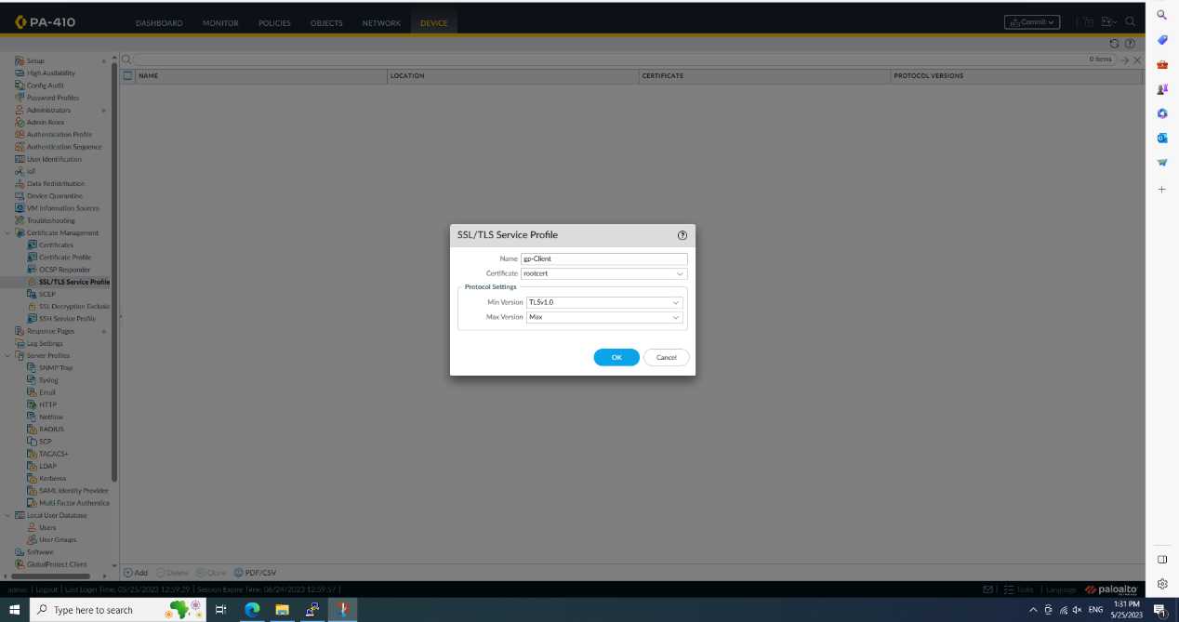

Create a local user

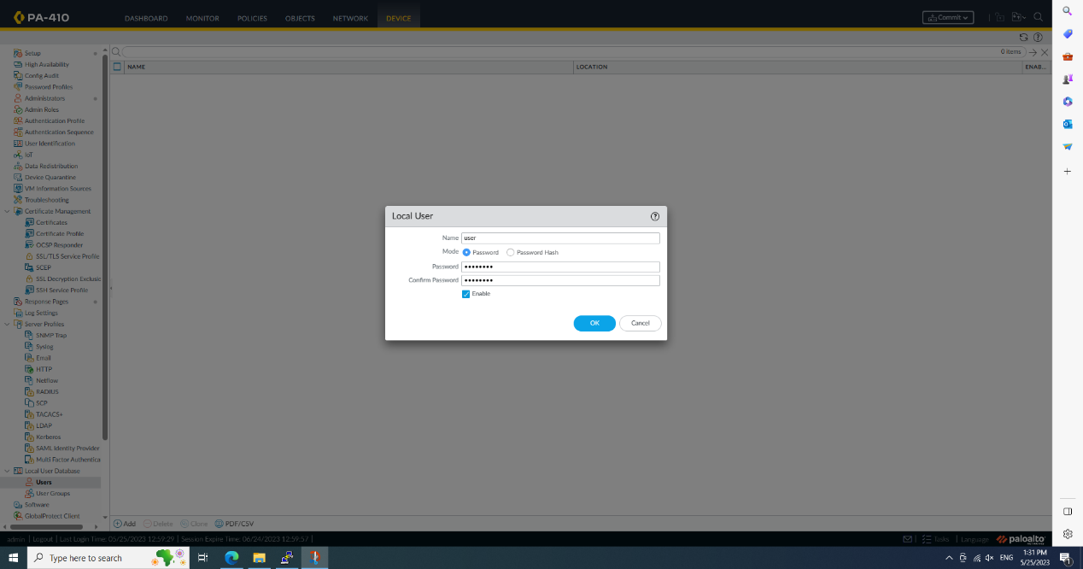

Add a authentication profile

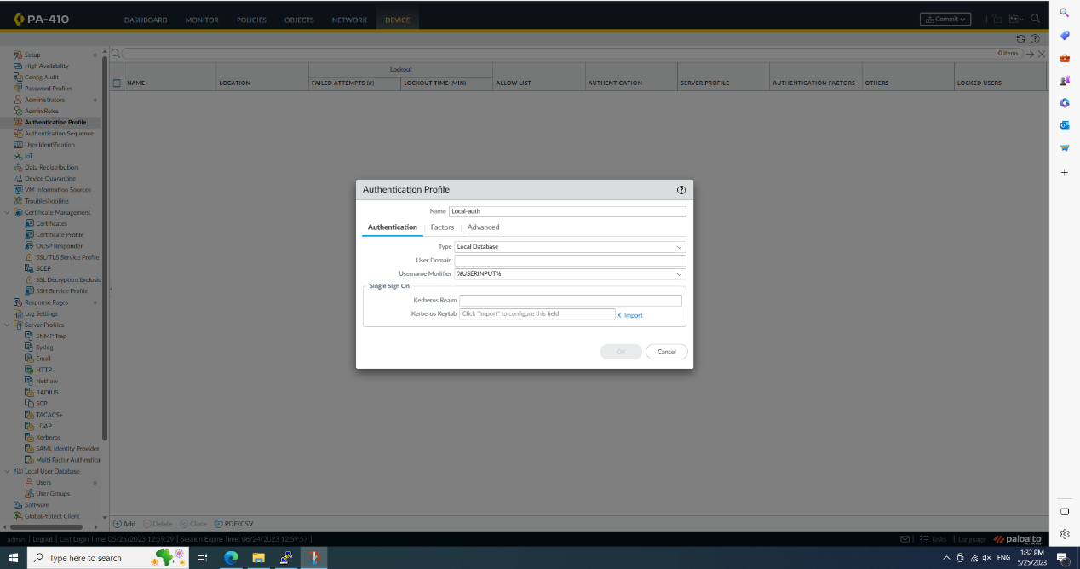

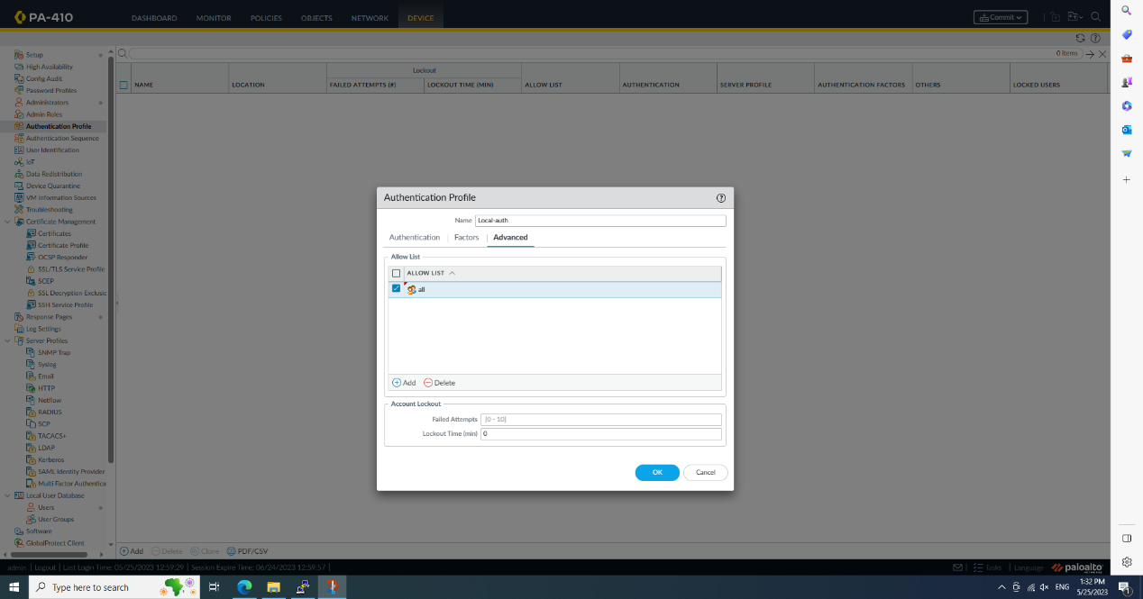

Add a new tunnel, don’t use the default one like this

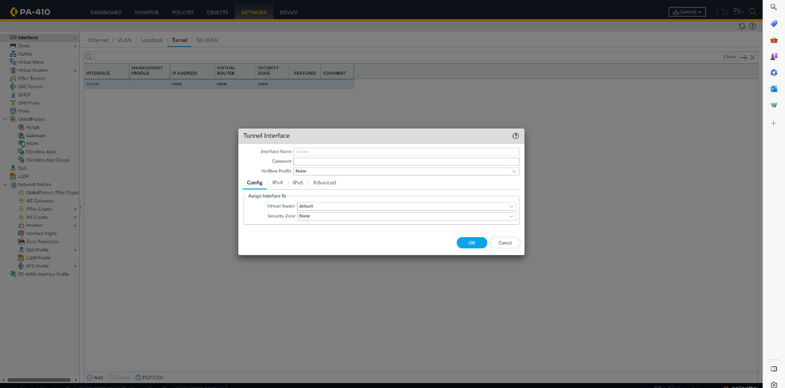

Create a new vpn zone

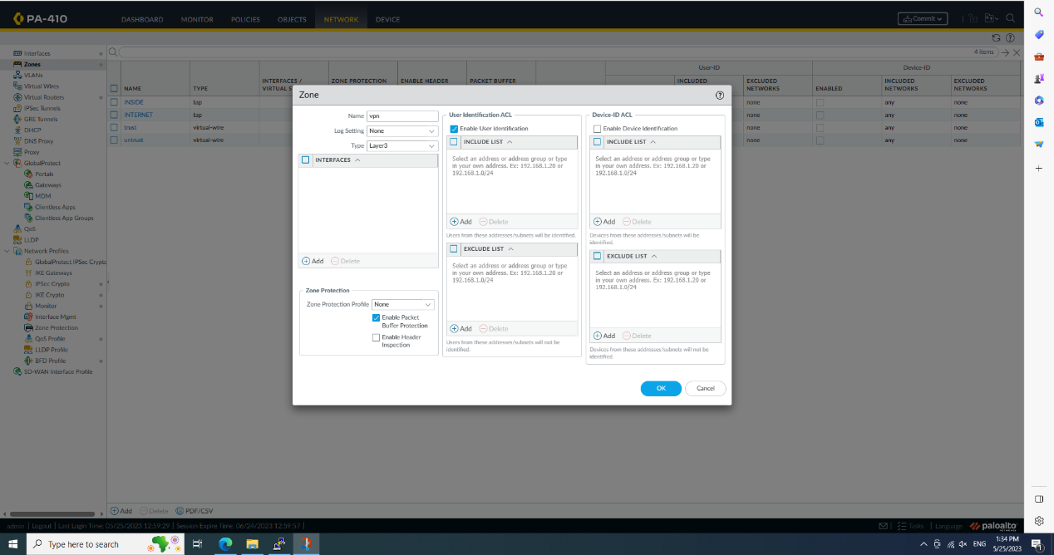

Create a global protect portal, ip address must be the same as the 1/1

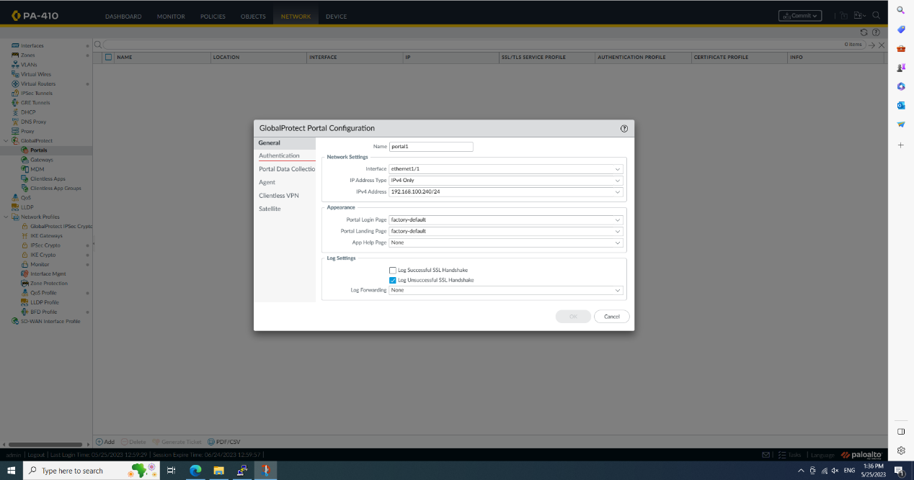

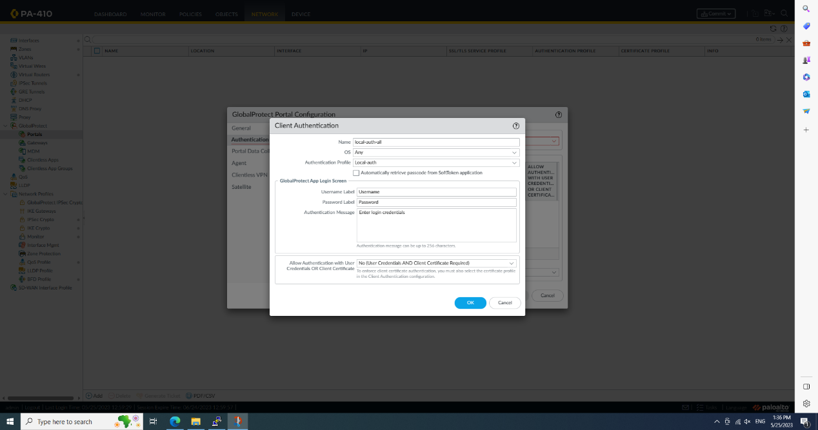

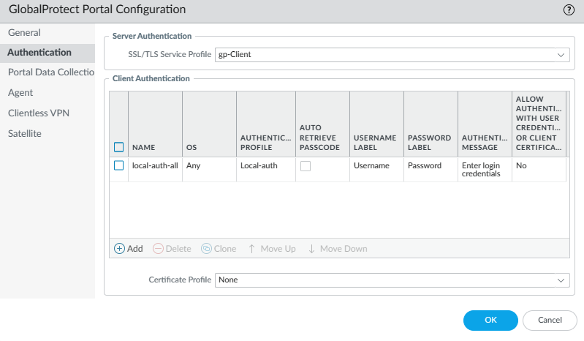

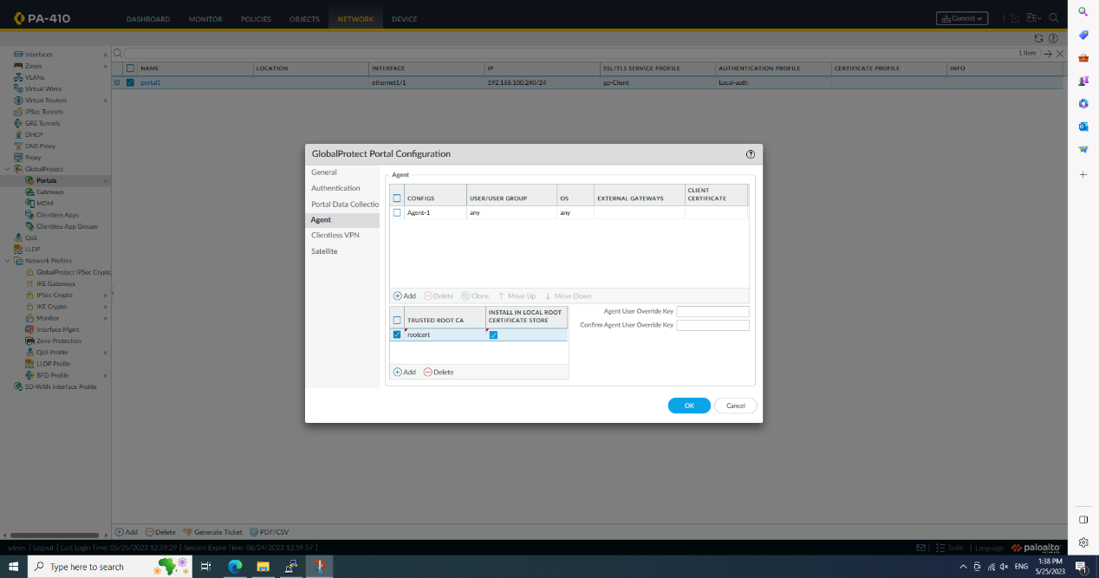

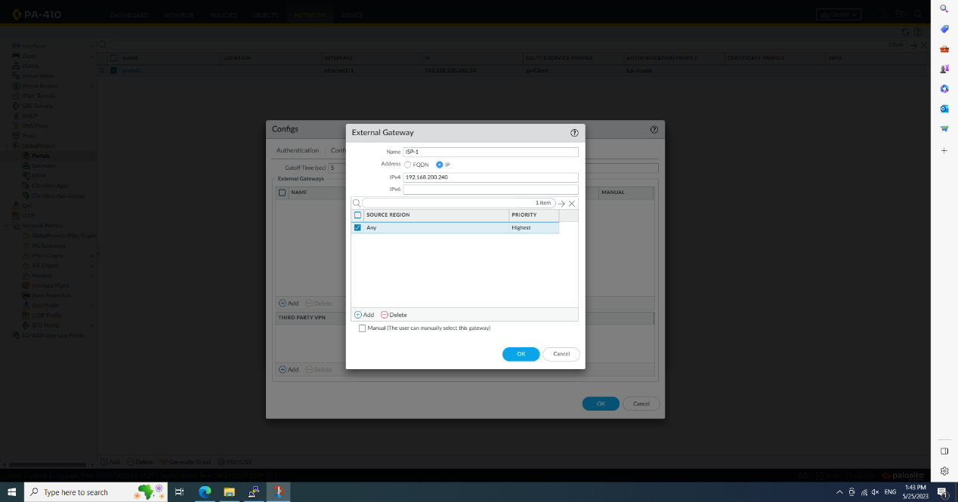

Add global protect gateway

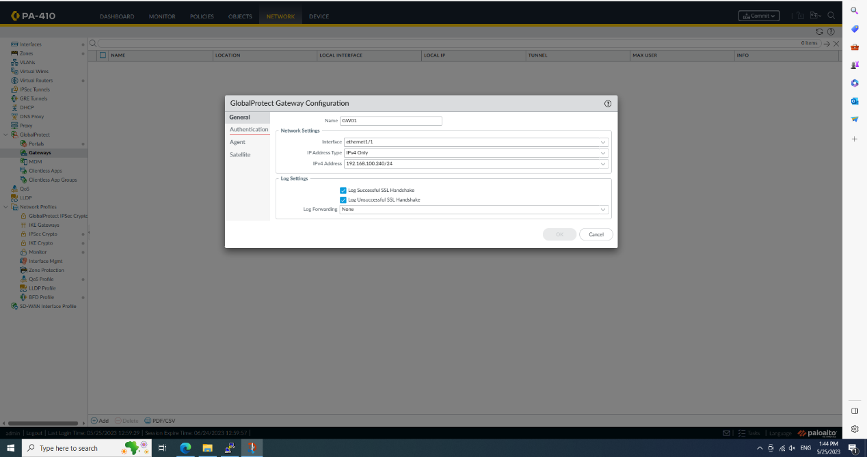

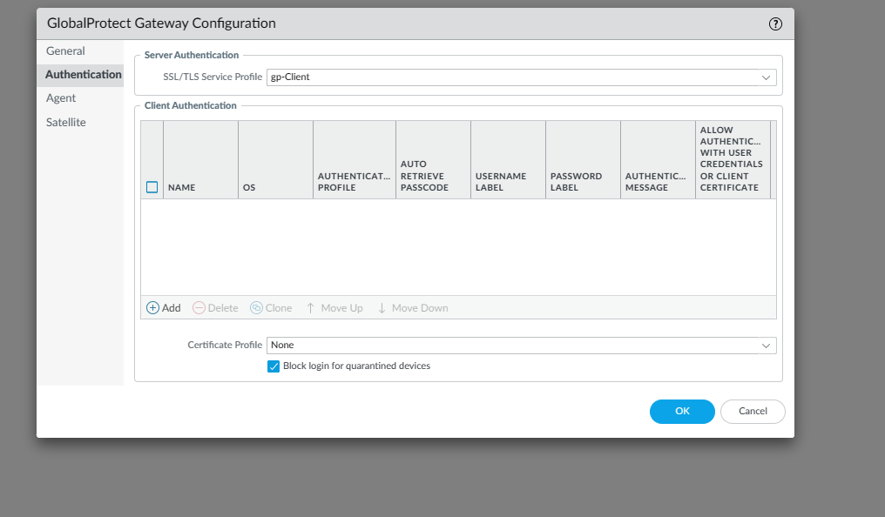

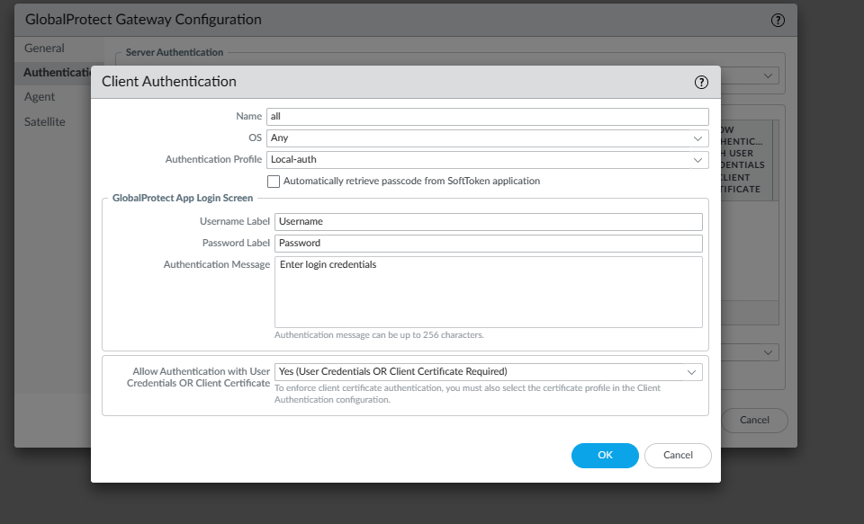

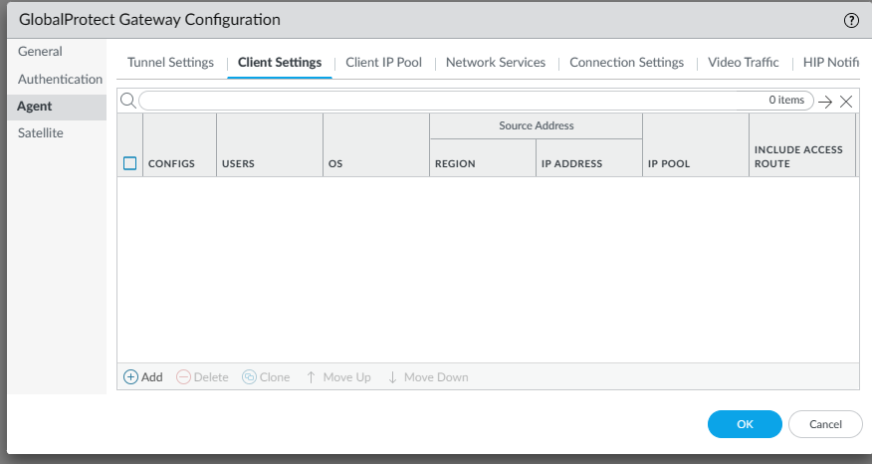

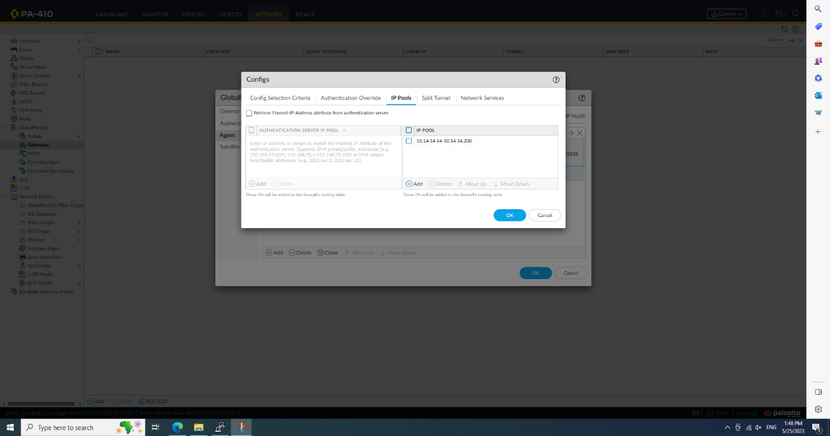

Update the lisence

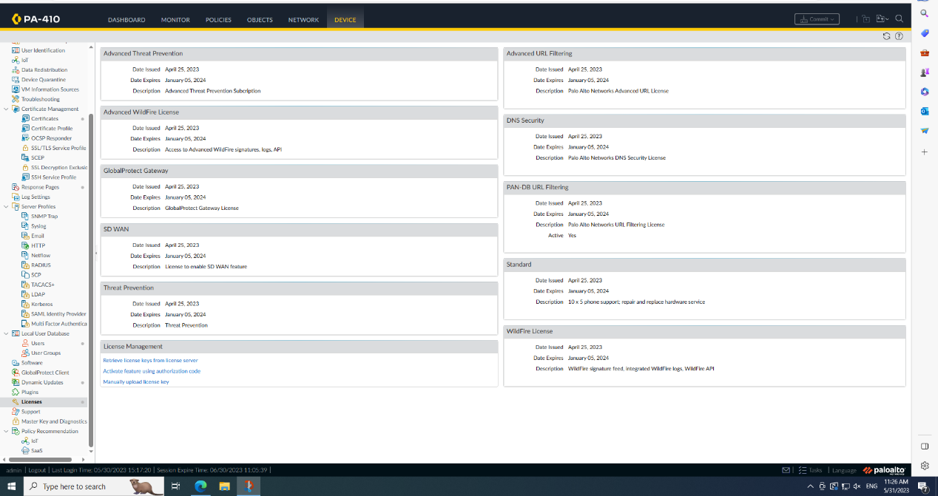

Download newest global protect version and install it

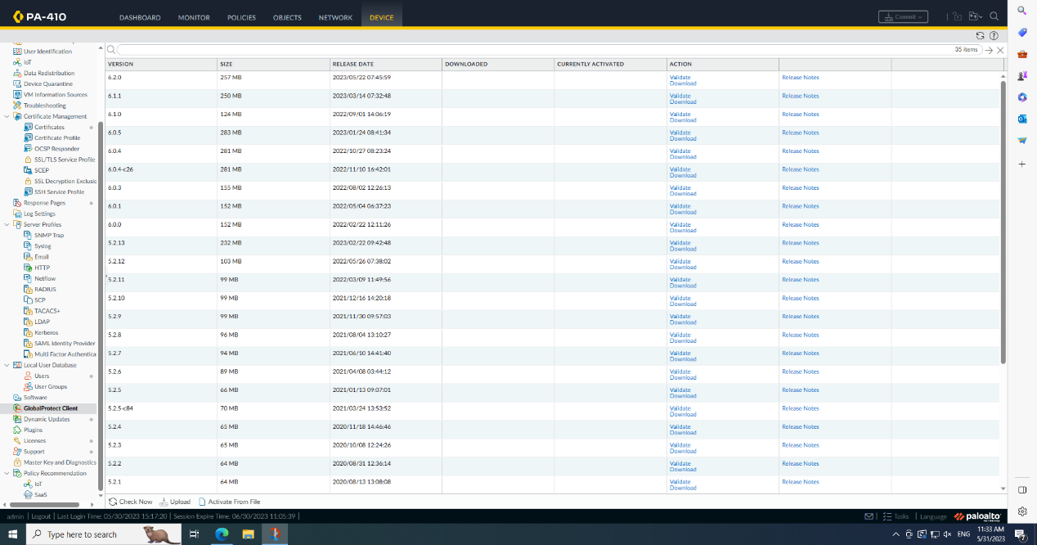

Log in remote user global protect, use the ip address that is assigned on outside port

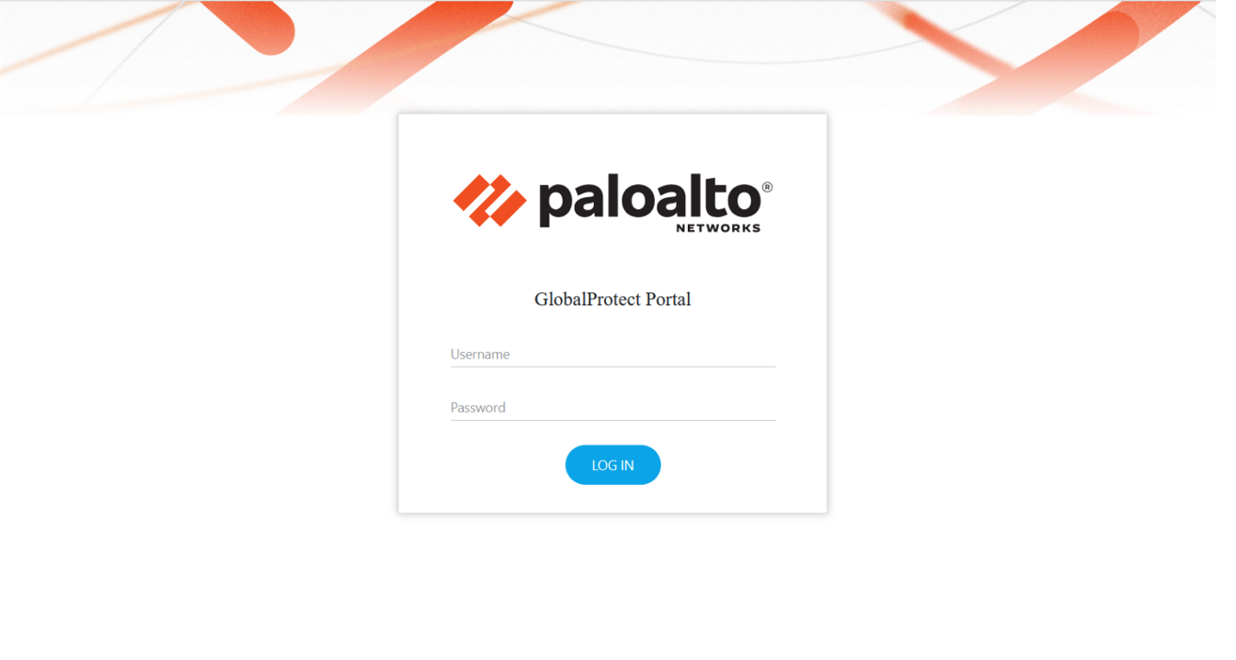

And download

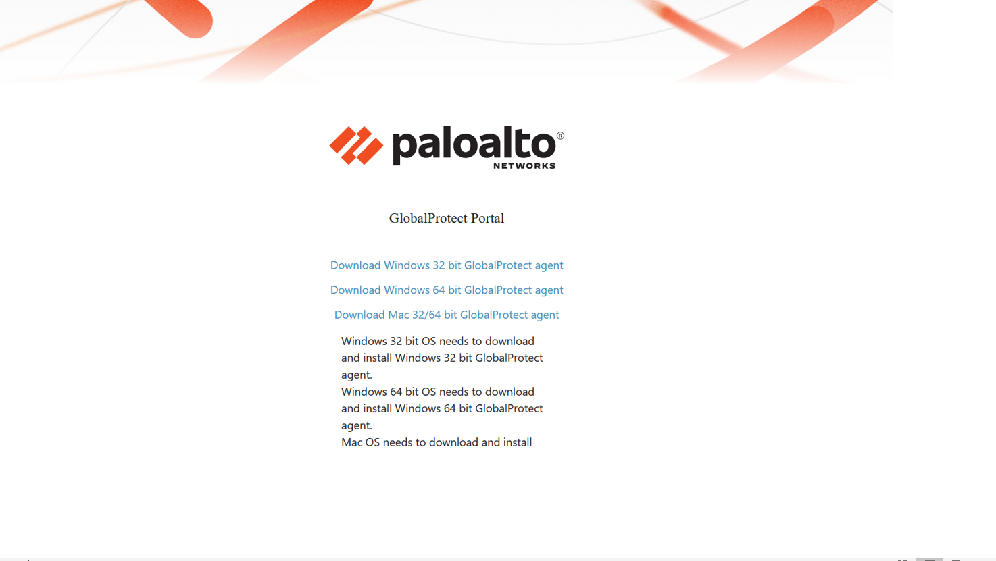

And install

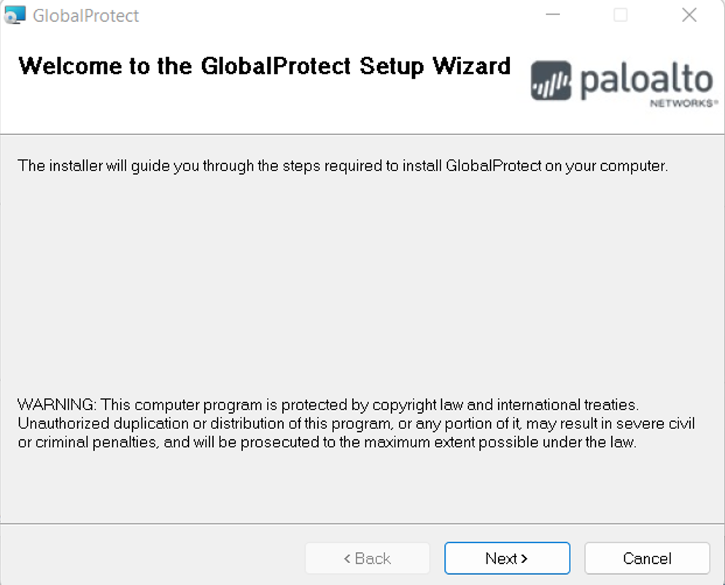

Open it once it finishes install

Connect it on other pc, should be somethings like this

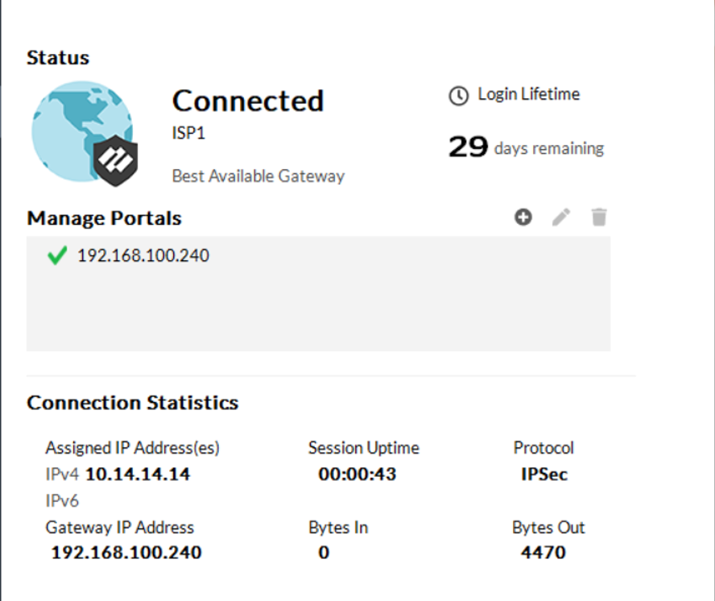

Problem:

I think the biggest problem is akshat... Well, you know, well, actually I'm quite negative

One obvious problem is that I followed the video, which used a static address, but then the firewall couldn't connect to the Internet, and it couldn't update lisence, or download and install the latest global protect, and if I enabled dhcp, this would cause a large part of the global protect settings to fail, and all the locations where the address was set were set every time I also seem to need an intermediate certificate and a server certificate, but I don't know how to create it, since they are both theoretically a branch of the root cert, but there is no such setup. Overall, I see that others have been able to do this, the only possibility is that the global protect was downloaded and installed ahead of time and then the address was switched back to a static address, I don't know if this works

Conclusion:

Compared with the site-to-site vpn cert, the cert vpn using remote access is really too complicated, because it requires the support of global protect. This software is an external software that requires networking. It is not similar to creating a site-to-site The certificate is then installed on each device and that's it

Lab 10

Set up a remote access vpn using SSL

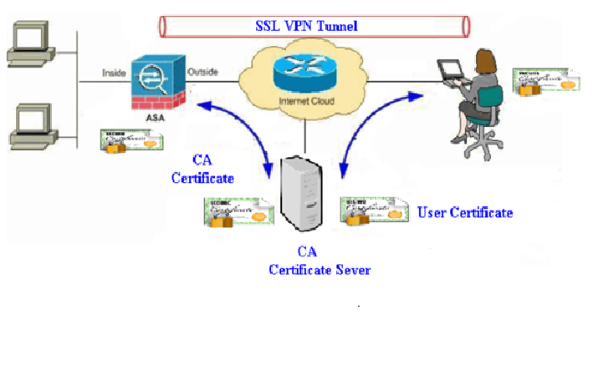**For some reason, I haven't even made progress on this lab yet**